**Module 3**

1. **Draw in detail the working of APD. Explain its merits and demerits**.? **Explain in detail** **working, principles of RAPD. Why it is called reach through APD? noise**

* In case of conventional photodiodes and PIN photodiodes the output current is very small. This is because these photodiode are having a limited gain. Now in order to obtain the large gain i.e. large output, the avalanche photodiodes are used.
* An APD is a very responsive semiconductor detector that used the photoelectric effect to change light into electricity. In 2020, a graphene layer is added to this diode to avoid degradation eventually to maintain these diodes.
* In fiber-optic communication systems, the light is changed into electrical signals using a single component like avalanche photodiode or APD. In the avalanche process, charge carriers are produced through collisions.
* A light particle-like photon generates many electrons to produce an electric current.

**Principle of operation**

* In this case the reverse bias applied to the photodiode is near to the breakdown value.
* The incident light produces the electron hole pairs. Now these carriers travels with their saturation velocity. Now when they travel with the maximum velocity, they will colloid with the lattice. So new electron hole pairs are generated.
* These newly generated carriers travels along with initial carriers. Thus the multiplication of charge carriers takes place which increases the current. This process of generating more number of charged carriers is called as impact ionization.

**Construction**

* The construction of reach through avalanche photodiode (RAPD)
* If the silicon material is used, the efficiency about 90 % is obtained.
* It is a p+π-p-n+ configuration as shown in Fig. 3.26.3.
* The construction of both the PIN photodiode and Avalanche photodiode is similar. This diode includes two heavily doped & two lightly doped regions. Here, heavily doped regions are P+ & N+ whereas lightly doped regions are I & P.
* In the intrinsic region, the depletion layer width is fairly thinner in this diode as compared to the PIN photodiode. Here, the p+ region works like the anode whereas the n+ region acts as the cathode. Here P layer is having high resistivity. So all the reverse bias is mostly applied across PN+ region.
* 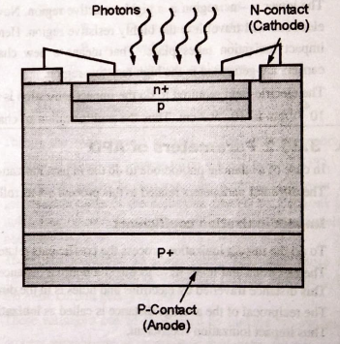When the applied reverse bias is increased, the width of the depletion region also gets increased.

**Working**

* The reverse bias is applied
* When the light is incident on the top p+ layer, the electron hole pairs are generated. More number of electron hole pairs are generated in the π layer.
* The charge carriers moves with their saturation velocity, because of the applied electric field.
* The lower p-n+ region is a highly resistive region. Now the electrons will travel into the highly resistive region. Here the impact ionization takes place. That means a new charged carriers are generated in the high resistive region.
* The electric field required to do the impact ionization is from 104 V/cm to 105 V/ cm. Thus the multiplication of charged carrier takes place. This increases the total photo current.
* Sometimes the gain up to 200 is obtained. Here the important factor is that the material should not have any defects. If such defects are present then the total photocurrent will gets reduced.

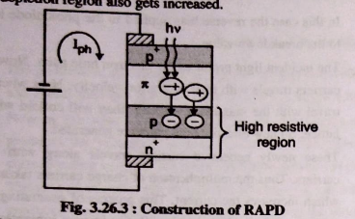

**Advantages**

* The sensitivity range is high.
* High performance.
* Quick response time.
* These diodes are applicable where the gain level is very important as the high voltage required.
* It detects low-intensity light.
* A single-photon generates a huge number of charge carrier pairs.

**Disadvantages**

* The required operating voltage is high
* The output of this diode is not linear
* High range of noise
* It is not used regularly because of the low reliability
* It uses high reverse bias for its proper operation

**Electric Field Profile**

* An electric field profile of RAPD is shown in fig.

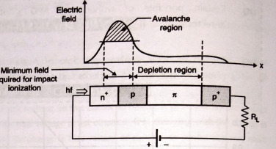

* A depletion region is created due to small applied electric voltage. If the reverse voltage is increased; the depletion region widens across p region and it reaches π region.
* The n region is much wider than p region; the electric field in π region is much lower than p – n+ region. This diode is normally operated in the fully depleted mode.
* The avalanche region is the gain region, which is created in the n+ - p region.

**Application:**

* Laser scanner
* Pet scanner
* Laser microscopy
* Barcode reader
* Speed Gun
* Analyzer bridge of antenna

**Noise Mechanism in APD:**

1. **Shot noise:**

* This noises is basically from the primary currents such as photo current, dark current and background current. Since these currents are primary currents they are not multiplied.
* So the value is small. Thus the value of shot noise is small.
* This current is given as

$$i_{shot}= \sqrt{2q \left(I_{ph}+I_{B} +I_{D}\right)∙G^{2}∙F∙B}$$

where q = charge of electron

Iph = photocurrent

IB = Background current

ID = Dark current

G = Gain of photodiode

F = Excess noise factor

B = Bandwidth

1. **Thermal noise**

The thermal noise is created because of the change in the resistance values of an APD. This is given by,

$$i_{thermal}= \sqrt{\frac{4 K T B}{R_{eq}}}$$

Here K = Boltzman's constant

T = The temperature of photodiode

B = Bandwidth

Req = Equivalent resistance

1. **Avalanche noise**

* This is the main source of noise. This noise is generated because of avalanche process taken place in case of APD.
* In case of avalanche process, the secondary carriers are generated because of the collisions created by electrons and holes. But the rate of generation of these secondary carriers is not fixed.
* There are variations in these rates. This will cause the variations in the number of secondary carriers generated. thus the noise current gets generated.
* These variations can be minimized by making the avalanche process asymmetric. A symmetric avalanche process means only one type of carriers that means either electrons or holes produces the secondary charge carriers.
* In other way if the ratio of electron ionization coefficient αe to the hole ionization coefficient αh is made maximum then it is possible that the avalanche process is asymmetric and the noise will be minimized.
* Thus to reduce the avalanche noise.

$$\frac{α_{e}}{α_{h}}= ∞$$

1. **Explain in detail working principle of PIN photodetector. Explain its merits and demerits?**

* As the name indicates, this diode consists of an undopped intrinsic layer between the two highly dopped regions.
* It gives improved performance as compared to conventional photodiodes.

**Construction**

* The construction of PIN photodiode is as shown in Fig.
* It consists of an undopped intrinsic i layer as shown in Fig.

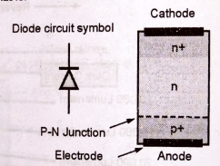

* The width of this layer is more than that of dopped P+ and N+ layers.
* The resistivity of 'i' layer ranges from 10 ohms per centimetre to 100 KΩ per centimetre. While the resistivity of dopped P+ and N+ layers is less than 1 Ω. This diode has much larger depletion area. The changes in the properties of the diode are known from the intrinsic material. These diodes are made of silicon.
* The intrinsic region of the PIN diode acts like an inferior rectifier which is used in various devices such as attenuators, photodetectors, fast switches, high voltage power circuits, etc.

**Working**

* The PIN diode does not provide any gain. So the maximum internal quantum efficiency is 100 %.
* The working principle of the PIN diode exactly same as a normal diode. The main difference is that the depletion region, because that normally exists between both the P & N regions in a reverse biased or unbiased diode is larger.
* In any PN junction diode, the P region contains holes as it has been doped to make sure that it has a majority of holes. Likewise the N-region has been doped to hold excess electrons.
* The layer between the P & N regions includes no charge carriers as any electrons or holes merge As the depletion region of the diode has no charge carriers it works as an insulator.
* The depletion region exists within a PIN diode, but if the PIN diode is forward biased, then the carriers come into the depletion region and as the two carrier types get together, the flow of current will starts.
* When the PIN diode is connected in forward biased, the charge carriers are very much higher than the level of intrinsic carrier's attention.
* Due to this reason the electric field and the high level injection level extends deeply into the region.
* This electric field assists in speeding up of the moving of charge carriers from P to N region, which consequences in quicker operation of the PIN diode, making it an appropriate device for high frequency operations.

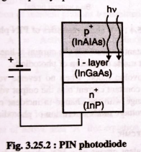

**Forward and Reverse characteristics of PIN Diode**

**Forward Biased PIN Diode**

* When the diode is kept forward biased, the charges are continuously injected into the I-region from the P and N region. This reduces the forward resistance of the diode, and it behaves like a variable resistance.
* The charge carrier which enters from P and N-region into the i-region are not immediately combined into the intrinsic region. The finite quantity of charge stored in the intrinsic
* region decreases their resistivity.
* Consider the Q be the quantity of charge stored in the depletion region. The τ be the time used for the recombination of the charges. The quantity of the charges stored in the intrinsic region depends on their recombination time. The forward current starts flowing into the IF region.

$$Q=I_{F} . τ$$

Where IF = Forward Current

τ = recombination time

The resistance (Rs) of the current under forwarding biased is inversely proportional to the charge Q stored in the intrinsic region.

$$R_{s}=\frac{ω}{\left(μ_{N}+ μ_{0}\right).Q}$$

Where, ω - width region

μ - electron mobility

μ0 - hole mobility

from equation 1 and 2 $$R_{s}=\frac{ω}{\left(μ_{N}+ μ_{0}\right). I_{F} τ }$$

The above equation shows that the resistance of the intrinsic region depends on the width of the region.

**Reversed Based PIN Diode**

* When the reverse voltage is applied across the diode, the width of the depletion region increases. The thickness of the region increases until the entire mobile charge carrier of the I-region swept away from it**. The reverse voltage requires for removing the complete charge carrier from the I-region is known as the swept voltage.**
* In reverse bias, the diode behaves like a capacitor. The P and N region acts as the positive and negative plates of the capacitor, and the intrinsic region is the insulator between the plates.

$$C=\frac{ϵA}{w}$$

**Advantages**

* Less noise
* Frequency response is good
* High reverse voltages to be accepted
* Less dark current
* Linear
* The depletion region is large
* Used as a variable resistance device
* The bias voltage is less
* Junction capacitance is low
* The response speed is high
* Responsive to the light

**Disadvantages**

* Less active area
* Reverse recovery time is high because of power loss
* Response time is not fast
* Less sensitivity
* There is no internal gain
* Temperature-dependent
* In dark current, it increases rapidly
* Needs amplification at less illumination region

**Noise current in PIN Photodiode**

1. **Photon noise**

* The photons incident on the photodiode does not have the same arrival rate. There are random fluctuations in the arrival rate. This causes the random fluctuations in the input signal. This in turn creates the random fluctuations in the output signal
* The noise current produced because of these fluctuations is called as photon noise current.

1. **Shot noise**

* The ambient light where the photodiode is placed is called as background radiation. This causes some photocurrent to flow, because of thermal generation of electron hole pairs in the depletion region. This dark current gives the random fluctuations in the output current.
* The current produced because of shot noise is called shot noise current and is given by.

$$I_{shot}= \sqrt{2 qB (I_{D} +I_{P})}$$

Where, q = charge of electron = 1.602 x 10-19 coulomb

ID = dark current

B = Bandwidth in Hz

Ip = photocurrent = $\frac{ η P_{0} Q λ }{h c}$

Here Po = Incident optical power

1. **Johnson noise**

* Under the thermal equilibrium, the charge carriers have the random motions.
* The noise current produced by these random motions is called as Johnson noise current and is given by,

$$I_{thermal}= \sqrt{\frac{4 KTB}{R_{T}}}$$

K = Boltzman's constant

= 8.62 x 10-5 eV/K

= 1.38 x 10-23  Joule / K

T = temperature in Kelvin and 1K = 273 *C

B = Bandwidth in Hz

RT = Total resistance i.e. Rsource + RLoad is ohm.

1. **Generation recombination noise**

* The fluctuations caused because of variations in the recombination rates of charged particles produces the generation recombination noise. This is generally very small.
* The total noise current is given by,
$$I_{total noise}={\left({\left(I_{thermal}\right)}^{2} +{\left(I_{shot}\right)}^{2}\right)}^{1/2}$$

* The signal to noise ratio is given by,

$$\left( \frac{S}{N} \right)=\frac{I_{signal}}{I_{noise}}=I_{P}^{2}/(I_{thermal}^{2} +(I_{total noise }^{2}×F_{n}))$$

Where Fn = amplifier noise figure

1. **Derive an expression for responsitivity of PIN photodiode.**

**Responsivity (R)**

This is the sensitivity of photodetector.

Responsivity is defined as the ratio of detector output to the detector input.

It is dependent on the wavelength of incoming light.

So this is also called as the spectral responsivity.

$$R=\frac{I_{ph}}{P_{inc}}$$

Where Iph = photocurrent and

Pinc = incident optical energy

$$R= \frac{ηλ \left(μm\right)}{1.24} (A/W)$$

Where $η$ = quantum efficiency of photodetector

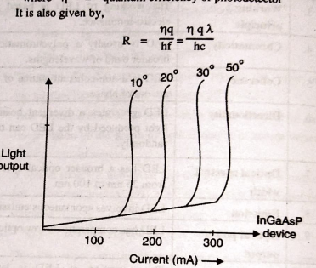It is also given by,

$$R=\frac{ηq}{hf}=\frac{η q λ}{hc}$$

1. **Quantum Efficiency**

It is defined as the ratio of number of newly generated charge carriers to the number of incident photons

$$η= \frac{Number of newly generated charge carriers}{Number of incident photons}$$

$$η=\frac{\left(\frac{{ I}_{ph}}{q}\right)}{\left(\frac{P_{inc}}{hf}\right)}$$

Here,

Iph = Generated photocurrent

q = charge of electron

Pin = Total incident optical power and

hf = Energy contained by photons

$$η_{ext}=\frac{I_{ph} . hf}{q{.P}_{inc}}$$

This is called as external quantum efficiency and denoted by $η_{ext}$.

The internal quantum efficiency $η_{1}$ is defined as the ratio of number of pairs created to the number of photons absorbed.

$$η_{1}=\frac{ Number of pairs generated}{Number of photons absorbed}$$

The value of internal quantum efficiency is high.

1. **Expression of Responsivity in terms of Quantum Efficiency and Wavelength.**

* The responsivity is basically ratio of output photocurrent to an incident optical power.

$R=\frac{I_{p}}{P_{opt}}$………………. (1)

* Now incident power of photodetector means output power of fiber optic cable.
* Energy contained in photons is E = hf; thus incident photon rate (rp) can be expressed in terms of incident optical power as,

$r_{p}=\frac{P_{opt}}{hf}$………………. (2)

* Now quantum efficiency is the ratio of number of electrons collected (re) to the number of incident photons (rp).

Equating Equations (1) and (2) we get,

$$\frac{r_{e}}{η}=\frac{p_{opt}}{hf}$$

$r_{e}=\frac{{η p}_{opt}}{hf}$…...............(3)

The output photocurrent is,

$$I_{p}=r_{e}.q$$

where q is charge of an electron

$I_{p}=\frac{ η P_{opt} q }{hf}$................(4)

Putting Equation (4) in Equation (1) we get,

$$R =\frac{η q}{hf}$$

But $f=\frac{c}{λ}$; where c = speed of light and

$λ$ = operating wavelength

$$R=\frac{η q λ}{hc}$$

This is the expression of responsivity in terms of quantum efficiency and wavelength.

Thus at a particular wavelength, responsivity is directly proportional to the quantum efficiency.

The plot of responsivity against wavelength is shown

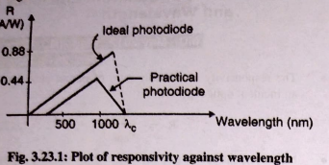

1. **Explain ELED and SLED. Compare it.**

|  |  |  |
| --- | --- | --- |
| Sr. No. | Surface Emitting LED | Edge Emitting LED |
| 1 | Light is emitted from the surface of the device. | Light is emitted from the edge of the device. |
| 2 | Active layer is sandwiched between two layers. | It has transparent guiding layers with thin active layers. |
| 3 | PAIGaAs performs optical confinement and avoids recombination process. | Light spreads into guiding layers, reducing self-absorption of the active region. |
| 4 | Less modulation bandwidth. | More modulation bandwidth. |
| 5 | Couples more optical power for large NA (Numerical Aperture). | Couples more optical power for low NA. |
| 6 | Emission pattern is isotropic. | Waveguiding narrows the beam divergence. |
| 7 | Easy to fabricate. | Difficult to fabricate. |
| 8 | Easy to mount and handle. | Difficult to mount and handle. |
| 9 | Requires less critical tolerance. | Needs critical tolerance during fabrication. |
| 10 | Less Reliable | Highly reliable. |
| 11 | Low system performance | High system performance. |
| 12 | Wide Spectral bandwidth | Narrow spectral bandwidth. |
| 13 | Maximum quantum efficiency is upto 60% | Internal quantum efficiency is in the range of 60% to 80%. |

1. **Compare LED and LASER**

|  |  |  |
| --- | --- | --- |
| **Basis of Difference** | **LED (Light Emitting Diode)** | **LASER (Light Amplification by Stimulated Emission of Radiation)** |
| Full form | Light Emitting Diode | Light Amplification by Stimulated Emission of Radiation |
| Definition | A semiconductor device that produces light when an electric current flows through it. | A device that emits light through optical amplification using stimulated emission of electromagnetic radiation. |
| Working principle | Based on electro-luminance. | Based on stimulated emission. |
| Chromaticity | Polychromatic (produces a broader band of wavelengths). | Monochromatic (generates light of a single wavelength). |
| Coherence | Non-coherent (photons are out of phase). | Coherent (photons are in phase). |
| Directionality | Generates a divergent beam of light.(all directions randomly) | Produces a non-divergent, highly directional beam of light. |
| Optical spectral width | Broader spectrum (usually ranging from 25 nm to 100 nm). | Narrower spectrum (usually 0.01 nm to 5 nm). |
| Emission power | Spontaneous emission. | Stimulated emission. |
| Temperature dependency of optical output power | Less dependent on temperature. | Temperature-dependent. |
| Conversion efficiency | Low (around 10 to 20 %) | High (around 30 to 70 %) |
| Reliability | High | Moderate |
| Drive circuit impact on eyes | Simple Circuit | Complex Circuit |
| Feedback power requirement | No feedback | There is a proper feedback |
| Response | Slow | Faster |
| Cost | Low | Expensive |
| Applications | LEDs are used in several applications such as area illumination, communication over moderate distances at low data rate, automobile headlamps, display screens, etc. | LASER is used in optical communication, welding, metal cutting, medical surgery, etc. |

1. **Explain the basic working principle of LASERs? LED**

* The term LASER stands for light amplification by stimulated emission of radiation. Here the word 'light' stands for the electromagnetic radiation which covers the range from ultraviolet region to the infrared region.
* The light has a dual nature. It consists of a wave nature and the energy. The energy contained by the light means, the number of photons contained by that light.
* The laser light is 'monochromatic' in nature. That means this light is having a single colour or single wavelength (mono means one and chroma means colour).
* Similarly this light is coherent in the nature, that mean all the wavelets contained in laser light are in the same phase.
* This is the major advantage of laser over ordinary light sources.
* The first successful laser was designed by 'Maiman' in 1960.
* After that several improvements were done and now-a-days various types of laser are available.
* That are ruby lasers, Gaseous lasers, power lasers, semiconductor lasers etc.

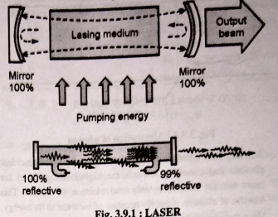

There are 3 basics steps to form laser beam:

1. **Abosrption**

* Under normal condition the tendency of electrons in case of the semiconducting material is to stay at the lower energy level. This lower energy level is called as ground state (E1).
* If the photon of certain energy is incident on this electron then the electron absorbs this energy. So the total energy contained by that electron gets increased and now it is possible for that electron to shift towards the higher energy level (Es).

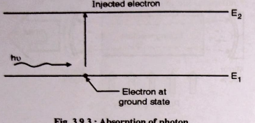

* Actually the number of electrons, absorbing the incident photons and travelling towards the higher energy level are more but for simplicity only one electron is shown. This transfer of electron is purely because of increase in its energy.
* Here the important consideration is that, the incident photon should provide sufficient energy to the electron to cause the motion of electron from E1 to E2. This sufficient energy in this case is the energy level difference between E1 and E2.
* That means the incident photon should provide atleast the energy E2 - E1. But if this much amount of energy is not provided by the incident photon, then the electron will absorb the energy, but it will not reach to the energy level E2.
* In this case the electron gets shifted and occupies an intermediate energy level between E1 and E2. This intermediate energy level is called as metastable state. And after sometime the electron falls back to its original energy level that is ground state.

1. **Spontaneous emission**

* After the absorption process the electron or atoms are present at the higher energy level that means they possess the excited state. Now if no incident light (that means photons) are provided externally then these electrons stays at this stage for a short time. But after some time period, the electrons falls back to its original stage that is lower energy level.
* Consider one electron present at the higher energy level. When this electron falls back to the lower energy level, it will emit the energy which was absorbed by it during the

absorption process. Thus it gives out the radiation.

* The energy emitted during this transition of electron from E2 to E1 is simply the energy level difference between these two energy levels. (that mean E2 - E1). This electrons falling back to ground state may directly comes to the ground state or it may follows 2 to 3 steps to reach to the ground state.

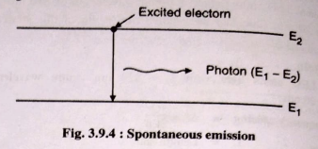

1. **Stimulated emission**

* This is the key process of the formation of laser beam. Because in this process only the amplification of light takes place. Consider the electron or atom present in the excited state. We have discussed that after certain time period this atom falls due to spontaneous process and emits a photon.
* But before the occurrence of this spontaneous emission process, if the incident photon is allowed to strike to this excited atom then there is no chance for this atom to go to the further higher energy level.
* In this case once the external photon strikes to this excited atom, this atoms leaves its position from this higher energy level and it will emit the photon. Thus we are getting two photons at the output one which is striking on the excited atom and other coming out because of the excited atom leaving the higher energy level.
* So one input photon causes the emission of two photons and the light amplification takes place. This process is shown in Fig.
* These two photons are in same phase and travelling in same direction.

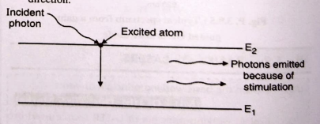

* Consider a box containing the excited atoms. Now if a photon that means a lightwave is applied to it as shown in Fig. then the stimulated emission takes place, and the light wave gets amplified.
* Here the important thing is that, the input light wave should be applied to the excited atom before the occurrence of spontaneous emission process.
* Otherwise no amplification of input wave will take place, rather in this case output wave will be having same amplitude as that of input wave.
* If instead of excited atoms, the atoms at the lower energy level are present in the box, then these atoms absorbs the energy from input wave and the amplitude of input wave gets reduced.
* So in this case to cause the amplification two conditions are necessary.

1. The input light wave (photons) should strike the excited atoms before the occurrence of spontaneous emission.
2. In the total structure the number of excited atoms should be more than that of atoms present at the ground level.

* The process in which the number of excited atoms made larger than that of the atoms present at ground state is called "population inversion".
* Similarly the time period for which the atoms present in this excited state should be made longer. This again makes easier to cause the stimulated emission.
* Thus in case of stimulated emission if number of atoms at the excited state are more, more number of photons are emitted. Thus causing amplification of light.
* All these photons are in same phase and are travelling in the same direction. Now this amplified light wave is called laser beam which is coherent and monochromatic in nature.

**LED**

* LED as the name indicates is a Light Emitting Diode. A light-emitting diode (LED) is a semiconductor device that emits light when an electric current flows through it.
* Here the light output is obtained at different currents and by the application of a low voltage. This light source emits the light of different wavelengths right from ultraviolet region of electromagnetic spectrum to the far infrared region.
* But practically LEDs can give out the wavelength upto 500 nm.
* LEDs are divided into two groups :

(a) Visible LED (b) Infrared LED

* Visible LEDs emits the light in the visible spectrum which generally ranges from 5600 A° to 7000 A°. While infrared LEDs emits the light in infrared region which generally ranges from 1.2 um to 9000 A°.

**Principle of operation**

* LEDs work on the principle of Electroluminescence. On passing a current through the diode, minority charge carriers and majority charge carriers recombine at the junction.
* On recombination, energy is released in the form of photons. As the forward voltage increases, the intensity of the light increases and reaches a maximum. Here in case of LEDs, the supply of higher level electrons is provided by the battery connection.

**Construction and Operation**

* The symbol and the forward biased LED is as shown in Fig.
* The lighting emitting diode is a p-n junction diode. It is a specially doped diode and made up of a special type of semiconductors with a suitable lens.
* The symbol of LED is shown in Fig.

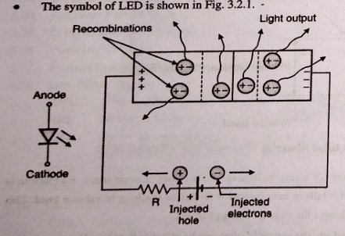

* The length of anode terminal is made longer than that of cathode terminal. As shown in Fig, the diode is made forward biased. Here the battery supplies the holes into 'p' region and electrons into 'n' region.
* These holes and electrons supplied by the battery are called as **injected charge carriers**. Now injected electrons, near the potential barrier gets recombined with the holes. That means the electrons are falling from higher energy level to lower energy level as shown in Fig

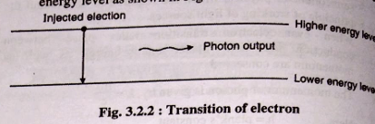

* When this transition occurs then the energy is radiated out. When the diode is forward biased, then the electrons & holes are moving fast across the junction and they are combined constantly, removing one another out.
* Soon after the electrons are moving from the n-type to the p- type silicon, it combines with the holes, then it disappears. Hence it makes the complete atom & more stable and it gives the little burst of energy in the form of a tiny packet or photon of light.
* In case of ordinary diodes, the recombination is also taking place. But the photons are not radiated. Only the heat is developed because of this recombination. But in case of LEDs because of the use of material such as gallium arsenide the photons are radiated out.
* Generally two types of transition takes place.

(a) Direct transition (b) Indirect transition

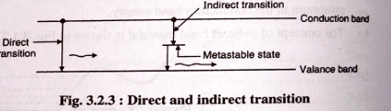

* In case of direct transition, the electron falls directly from higher energy level (conduction band) to the lower energy level (valance band).
* But in case of indirect transition, because of difference in the momenta of electron and holes, the electron when falling from conduction band stops at intermediate energy level (called as metastable state) for a certain time and then it will reach to the valance band. So definitely time required for indirect transition is more than that of direct transition.

1. **Differentiate PIN and APD? Differentiate PIN and RAPD?**

|  |  |  |
| --- | --- | --- |
| **Parameters** | **PIN Photodiodes** | **Avalanche Photodiodes** |
| Layer | An undoped intrinsic layer (i) is placed between two highly doped regions. | Here, a “π” layer is placed between p and n regions. |
| Gain | Gain is not provided. | More gain is provided. |
| External Amplifier | Amplifier is required to connect externally. | No external amplifier is required. |
| Response Time | Response time is less. | More response time. |
| Output Current | Output current is small. | More output current is obtained. |
| Sensitivity | Sensitivity is less. | Higher sensitivity. |
| Reverse bias | Low reverse bias is required. | High reverse bias is required. |
| Temperature | Good temperature stability. | Poor temperature stability. |
| Noise Current | Different noise currents are photon noise, shot noise, Johnson noise and generation recombination noise. | Different noise currents are shot noise, thermal noise and avalanche noise. |

1. **Sketch a neat Surface emitting LED and explain.**

* The technique pioneered by Burrus and Dawson with homostructure devices was to use an etched well in a GaAs substrate in order to prevent heavy absorption of the emitted radiation, and physically to accommodate the fiber.
* These structures have a low thermal impedance in the active region allowing high current densities and giving high-radiance emission into the optical fiber. As the name indicates; the light is emitted from the surface of LED structure.
* The plant of light emitting surface is placed in a perpendicular direction to the axis of optical fiber.
* Thus the light from LED can be directly coupled into the optical fiber. The structure of Double Heterodyne (DH) surface emitting LED is as shown in Fig.
* The SiO2 layer acts as insulator between p GaAs and metal. The layer of p-AlGaAs is used to avoid recombinations and used to perform optical confinement. In this structure, a well is etched through the substrate of device and the optical fiber is cemented into it. A microlens is placed on the LED to improve coupling efficiency.

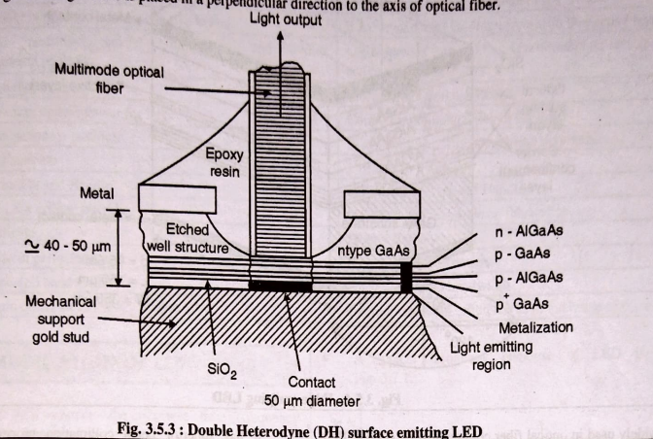

* The light emitted from the LED is directly coupled to the fiber. By using etching, the distance between active region and emitting surface is minimized.
* The different properties of surface emitter LED are :

1. High radiance is obtained.
2. Low terminal impedance is obtained in the active region.
3. Due to Double Heterojunction (DH); the coupling efficiency (n) is increased.
4. Emission pattern is isotropic with 120° half power beam width.

* This pattern is called as **Lambertian pattern.**

**Advantages:**

* Optical coupling coefficient of LED with external fiber system is relatively higher. Hence this LED offers high optical coupling efficiency.
* Optical loss (due to internal absorption) is very low. This is because of carrier recombination near its top heterojunction.
* InP/InGaAsP based LED is used for long wavelength applications.
* It offers higher efficiency with low to high radiance.
* The top n-GaAs contact layer ensures low thermal resistance and contact resistance. This allows high current densities and high radiation intensity.
* The internal absorption in the device is very low due to larger bandgap confining layers. Moreover reflection coefficient at the back crystal face is high which gives good forward radiance.

**Disadvantages**

* The surface emitting LED can transmit data rate less than 20 Mbps than edge emitting LED.
* It contains short optical link with large NA (Numerical Aperture).
* If the active layer temperature is increased then lifetime of LED is decreased.

1. **Write short note on quantum well laser.**

* A quantum well can be created by sandwiching a semiconductor, let's call it semiconductor A, betwen semiconductors B shown in Fig.
* The left diagram in this picture shows the structure of quantum well laser where semiconductors A and B are stacked along z- direction. To créate a quantum well along z-direction, semiconductor
* A must have a smaller band gap as compared to semiconductor, BEgap, A<Egap, B, shown if Fig. 3.13.4 on the right (be aware of where z-direction is) . The size of this well is normally at the order of 20 nm or less for quantum property to emerge. Consequently, the energy levels of electrons and holes in the well become quantized (discrete energy levels).

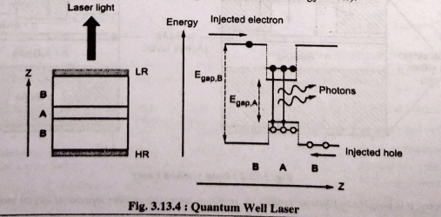

**Working of Quantum Well laser**

* When a current is applied to the quantumn well, holes and electrons will be injected into the quantum well. This creates a population inversion of electrons and holes near the higher energy level and lower energy level, respectively. Subsequently, electrons will spontaneously recombine with holes and emit photons. These emitted photons will induce more recombination of electrons and holes (stimulated emission) which leads to more photons.
* Population inversion alone is not sufficient for lasing to occur, one needs an optical cavity as well. In QW laser, different types of reflectors (e.g. Bragg reflector) are used to
* achieve this. In the left diagram, these reflectors are represented by the grey layers. At the bottom, there is a high reflective (HR) layer while on top, there is a low reflective
* (LR) layer. With this optical cavity, spontaneously emitted photons will be bounced back and forth along the z-direction, triggering more stimulated emissions. This will amplify the number of photons needed for lasing. Since the top reflector has a lower reflectivity, photons (laser light) in the cavity will be emitted through this layer. A stable laser light will only be generated when the gain exceeds the round trip loss.
* In fact, adopting a quantum well structure improves the probability of electron-hole recombination which is one of the contributions to the low threshold current in QW laser. On top of that, if several single quantum well are arranged parallel to one another, a multiple quantum well (MQW) laser can be created. A MQW laser can give rise to a larger output power and a smaller threshold current in view of its improved optical confinement factor and increase in the density of states.

**Advantages of Quantum Well Lasers compared to conventional Lasers**

1. Less forward current is required for the formation of laser beam.
2. High quantum gain and high output power is obtained.
3. It has low threshold current.
4. Under pulsed condition; frequency stability is obtained.
5. The line widths are narrower.
6. Higher modulation speeds are obtained.
7. Low noise is generated.
8. It is less temperature dependant.
9. **Rise time budget**

* The purpose of the rise-time budget is to ensure that the system is able to operate properly at the intended bit rate. Even if the bandwidth of the individual system components exceeds the bit rate, it is still possible that the total system may not be able to operate at that bit rate.
* The concept of rise time is used to allocate the bandwidth among various components. The rise time T, of a linear system is defined as the time during which the response increases from 10 to 90% of its final output value when the input is changed abruptly. Fig. 3.39.2 shown the concept graphically.

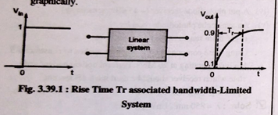

* The rise time budget is used to determine the dispersion limitation of an optical link. The total rise time of a link is denoted by tsys and it is given by,
$$t_{sys}= \sqrt{\sum_{i =1 }^{N}{t_{i}^{2}}}$$

* Here 'ti' is the rise time contributed by each element of a link.
* There are four basic elements which limit the speed of a system. These elements are in follows:
  + Transmitter rise time
  + Group velocity dispersion rise time
  + Modal dispersion rise time
  + Receiver rise time

1. **Transmitter rise time (ttx)**

This type of rise time is contributed by the light source and its driving circuitry. This value is generally known to the designer.

1. **Group velocity dispersion rise time (tmat)**

The total optical link is formed from several sub-sections of optical fiber. Each fiber produces its own dispersion. So it becomes difficult to calculate the group delay dispersion rise time of entire fiber cable.

For length 'L' of optical cable; this rise time is approximately given by,

$t_{mat}=D L σ_{λ}$.......................... (1)

Here, D = Dispersion of optical link

L = Length of optical link

$σ_{λ}$ = Half power spectral width of light source.

1. **Modal dispersion rise time (tmod)**

The modal dispersion rise time is given by,

$t_{mod}=\frac{440}{B_{M}}$........................ (2)

Here BM is the bandwidth of optical link of length L. Using empirical relation, it can be expressed as,

$B_{M}=\frac{B_{0}}{L^{q}}$........................ (3)

Here Bo = Bandwidth of 1 km length of cable.

q = parameter ranging between 0.5 and 1.

If q = 0.5 then it indicates that Q steady state modal equilibrium has been reached. And if q = 1 then it indicates a little mode mixing.

Putting Equation (2) in Equation (3) we get,

$t_{mod}=\frac{440 L^{q}}{B_{0}}$....................(4)

If tmod is expressed in nanoseconds and bandwidth is given in MHz then Equation (4) can be written as,

$$t_{mod}=\frac{440 L^{q}}{B_{0}}$$

1. **Receiver rise time (trx)**

It results from the photodetector response and 3-dB electrical bandwidth of receiver front end.

If 3-dB electrical bandwidth (Brx ) of receiver is expressed is MHz then trx is given by,

$$t_{rx}=\frac{350}{B_{rx}}$$

Now, according to Equation (3.39.1), the total rise time of system is,

$$t_{sys}= \sqrt{t_{tx}^{2}+ t_{mod}^{2}+ t_{mat}^{2}+ t_{rx}^{2}}$$

$$t_{sys}= {\left[t_{tx}^{2}+ {\left(\frac{440 L^{q}}{B_{0}}\right)}^{2}+D^{2} σ_{λ}^{2} L^{2} {\left(\frac{350}{B_{rx}}\right)}^{2} \right]}^{1/2}$$

In case of RZ (Return to Zero) format, the bandwidth and total system rise time are related by $$Bandwidth=B_{Tmax}=\frac{0.35}{T_{sys }}$$

In case of NRZ (Non Return to Zero) format; bandwidth and total system rise time are related by,

$$B_{Tmax}=\frac{0.70}{T_{sys }}$$

1. **Link budget**

* The optical power budget in a fiber-optic communication link is the allocation of available optical power (launched into a given fiber by a given source) among various loss-producing mechanisms such as launch coupling loss, fiber attenuation, splice losses and connector losses, to ensure that adequate signal strength (optical power) is available at the receiver.
* When optical fiber link is used for communication purpose then the total loss in the system is the addition of losses taking place because of all components.
* The loss produced by every elements in the system is expressed in dB.
* It is given as,

Loss (in dB) = $10\log_{10}{\frac{P_{out}}{p_{in}}}$

Here, Pout = Output power from the element

Pin = Input power to the element

* Optical power loss model is as shown in Fig. In this particular model the connectors are used at the transmitter and receiver section.

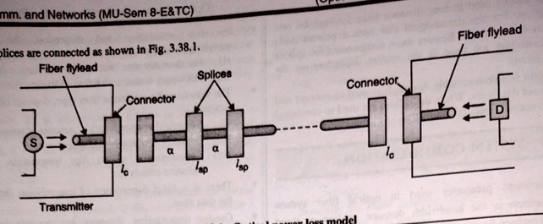

Here

S = Light source

D = Detector

lc = Losses taking place at connector

lsp = Losses taking place at splices

α = Attenuation loss taking place in optical fiber.

* For the simplicity, other losses in optical fiber cable are neglected. Only the losses taking place because of attenuation are considered. Here to find out the total loss, the loss contributed by each element in the system is considered.
* Besides this the system margin is added. This is because, in future due to aging of components or due to temperature variations more losses may be added in the system. Similarly the portion of optical fiber connected to source and detector may adds some losses. This portion of optical fiber is called as fiber flylead.
* The loss contributed by fiber flylead is considered as 1 dB. The system margin is generally considered to be equals to 6-8 đB.
* Thus the total power loss in a point to point link is given as,

$P_{T}=P_{S}-P_{R}$..................... (1)

Here Ps = Optical power coming from the end of flylead attached to light source

PR = Sensitivity of receiver.

Thus Equation (1) can also be written as,

$$P_{T}=(2 l_{c}+α L+System margin)$$

Here,

lc = Losses taking place at the connector.

l = Length of optical fiber.

α = Attenuation taking place in optical fiber.

**Module 4**

1. **Explain different types of front end amplifiers**

**Optical amplifiers**

* In between transmitter and receiver; to boost the power of signal, different amplifiers are required.
* A general representation of a fiber amplifier is shown in Fig.

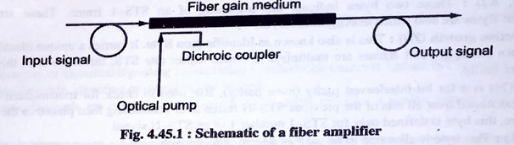

* The gain medium normally comprises a length of single-mode fiber connected to a dichroic coupler which provides low insertion loss at both signal and pump wavelengths.
* Excitation occurs through optical pumping from a high-power solid-state or semiconductor laser which is combined with the optical input signal within the coupler. The amplified optical signal is therefore emitted from the other end of the gain medium.
* Optical amplifiers are placed at intervals along a fiber link to provide linear amplification of the transmitted optical signal.
* The optical amplifier, in principle, provides a much simpler solution in that it is a single in-line component which can be used for any kind of modulation at virtually any transmission rate.
* The Erbium Dopped Fiber Amplifier (EDFA) is most commonly used optical amplifiers in majority application.
* The basic amplifier configurations that are used in optical fiber communication are front end amplifiers. Different categories of front end amplifiers are as follows:
* Low impedance front-end amplifier
* High impedance front-end amplifier
* Trans impedance front-end amplifier

**Low-impedance front-end amplifier**

* Three basic amplifier configurations are frequently used in optical fiber communication receivers.
* The simplest, and perhaps the most common, is the voltage amplifier with an effective input resistance Ra as shown in Fig.
* In order to make suitable design choices, it is necessary to consider both bandwidth and noise.
* However, in most practical receivers the detector is loaded with a bias resistor Rb and an amplifier

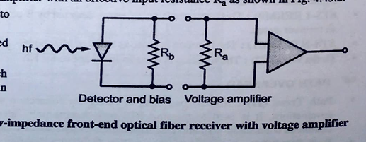

* The bandwidth is determined by the passive impedance which appears across the detector terminals which is taken as RL in the bandwidth relationship.
* However, RL may be modified to incorporate the parallel resistance of the detector bias resistor Rb and the amplifier input resistance Ra . The modified total load resistance RTL is therefore given by:
$$R_{TL}=\frac{R_{b} R_{a}}{R_{b}+R_{a}}$$

* To achieve an optimum bandwidth both Rb and Ra must be minimized.

**High-impedance (integrating) front-end amplifier**

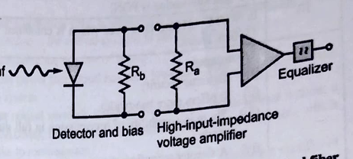

* The second configuration consists of a high input impedance amplifier together with a large detector bias resistor in order to reduce the effect of thermal noise.
* However, this structure tends to give a degraded frequency response as the bandwidth relationship is not maintained for wideband
* The detector output is effectively integrated over a large time constant and must be restored by differentiation.
* This may be performed by the correct equalization at a later stage as illustrated in Fig.
* Therefore the high-impedance (integrating) front-end structure gives a significant improvement in sensitivity over the low-impedance front-end design, but it creates a heavy demand for equalization and has problems of limited dynamic range (the ratio of maximum to minimum input signals).

**The Trans impedance front-end amplifier**

* This configuration largely overcomes the drawbacks of the high-impedance front end by utilizing a low-noise, high-input-impedance amplifier with negative feedback.
* The device therefore operates as a current mode amplifier where the high input impedance is reduced by negative feedback.
* An equivalent circuit for an optical fiber receiver incorporating a transimpedance front-end structure is shown in Fig.
* In this equivalent circuit the parallel resistances and capacitances are combined into RTL and CT respectively. The open loop current to voltage transfer function HOL (ω) for this transimpedance configuration corresponds to the transfer function for the two structures.

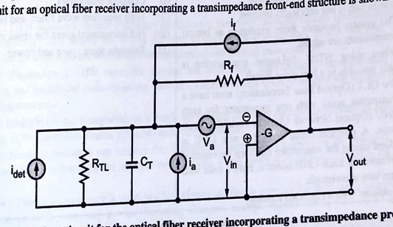

1. **What are optical amplifiers? Explain EDFA, application, working principle, advantages? Sketch diagram of RAMAN amplifier and its applications?**

* As the name indicates; optical amplifiers are used to amplify the optical signal. In case of optical amplifier; it is not necessary to convert optical signal into electrical and then provide the amplification.
* Optical amplifiers performs amplification without any conversion. Optical amplifiers are placed throughout the optical length; to provide amplification.
* Optical amplifiers are bidirectional and optical multiplexing is also possible. That means optical amplifier accepts many signal of different wavelength and provides amplification.
* Broadly there are two types of optical amplifiers, namely semiconductor optical amplifier and Raman amplifiers.
* Semiconductor optical amplifiers are small in size and provides amplification by using stimulated emission; which is similar to laser.
* Raman amplifier makes use of Raman scattering principle to obtain optically amplified signal.

1. Erbium Dopped Fiber Amplifiers (EDFA)
2. Semiconductor Optical Amplifier (SOA)
3. Raman Amplifiers
4. Wideband Fiber Amplifiers

**EDFA**

* Such optical amplifiers make use of erbium ions ($E_{r}^{3+})$ core layer of optical cable.
* Input optical signal, which is to be amplified is mixed with high powered beam of light. This is called as pump light. This mixing is done using wavelength selective couplers. Both the signals, namely input signal to be amplified and high powered beam of light are having different wavelengths. This signal is then passed through the optical cable containing eribium ions.
* The erbium ions, absorb energy and get excited to higher energy levels. When the photons of pump light strikes the erbium atoms; the erbium atoms give optical energy to the striking photons. This optical energy given by erbium atoms is in the form of photons and these new photos are in phase. So, optical amplification takes place and amplified light travels in the forward direction. In order to avoid back reflections; optical insulator is placed at the output.

**Energy Level Diagram of $E_{r}^{3+}$ ions**

* The energy level diagram and transition process of E ions in silica is shown in Fig. Erbium atoms in the silica are $E_{r}^{3+}$ ions, which are basically electrons.
* This erbium ions are raised to higher energy levels by using a pumping light. The differen transition states are shown in Fig.

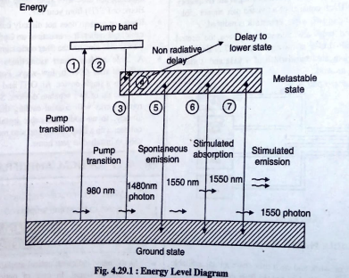

* **Transition 1:** It represents the pump transition and in this case 980 nm photons emitting laser is used for pumping. Due to absorption of incoming energy; erbium ions are excited from ground state to the pump level.
* **Transition 2:** Due to mechanical vibrations in optical cable; there is quick decay of excited ions from pump level to the metastable state. This is non radiative decay.
* **Transition 3**: The applied wavelength is 1480 nm. Due to absorption of this energy; erbium ions are excited from ground state to the metastable state.
* **Transition 4:** It represents the decay to the lower state of same metastable band.
* **Transition 5:** Some of the ions from metastable state falls back to the ground state due to spontaneous emission.
* **Transition 6:** The ions in the ground state absorps external photons and get excited to metastable state.
* **Transition 7:** Due to stimulated emission; new photons of same energy and polarization is created around 1530 nm.

**Application:**

* Long-haul optical communication networks
* Metro and Access Networks
* Cable Television System

.

**Advantages:**

* **High Gain:** Provide high amplification for signals transmitted over long distances without the need for frequent regeneration.
* **Wide Bandwidth**: Amplify a broad range of wavelengths simultaneously, enabling wavelength-division multiplexing (WDM) in fiber-optic networks.
* **Low Noise:** Offer low noise figure, preserving the quality of the amplified signals.
* **Reliable:** Robust and mature technology with proven reliability, suitable for deployment in telecommunications infrastructure.

**RAMAN amplifier**

* This optical amplifier works on the principle called as Stimulated Raman Scattering (SRS). When an atom is in ground state and it absorbs, the photon having a particular energy level. But when the atom falls back from excited state to the ground state; it emits the photon having different-energy
* Due to the difference in these energy levels; the vibration of optical cable takes place. The SRS effect occurs, whenever there is interaction between optical energy field and vibrational modes of cable. There are two types of Raman amplifiers; namely distributed Raman amplifier and lumped Raman amplifier.
* In distributed Raman amplifier; the pump wavelength and signal wavelength are multiplexed in optical cable. Here the transmission fiber is used as a gain medium. In lamped Raman amplifier; the interaction between signal and pump level is increased by using non-linear fiber having small core.
* The gain in this amplification is called as Raman gain and it depends on the factors like fiber length, fiber attenuation and the core diameter. By using low loss fibers; Raman gain can be increased. Raman gain can also be increased by decreasing the core diameter of optical cable**.**

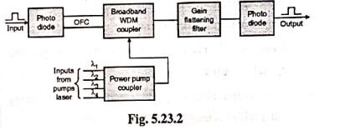

**Application:**

* Long-haul and ultra-long-haul optical communication systems.
* Optical Sensors
* Biomedical Imaging

**Advantages:**

* **Distributed Amplification:** Provide distributed amplification along the length of the optical fiber, reducing the need for discrete amplifiers**.**
* **Wavelength Flexibility**: Amplify signals across a wide range of wavelengths, compatible with wavelength-division multiplexing (WDM) systems**.**
* **Low Nonlinear Effects:** Reduce nonlinear impairments such as four-wave mixing and cross-phase modulation, improving signal quality.
* **Energy Efficient:** Operate at lower pump powers compared to other amplification technologies, leading to reduced power consumption.

**Semiconductor Optical Amplifier (SOA)**

* In case of lasers; amplification of light takes place, when thelight beam causes many reflections between two end faces. In case of Semiconductor Optical Amplifier (SOA); the amplification action takes place without many reflections.
* SOA is basically InGaAsP laser diode, which is operating below the threshold point. By changing the composition of InGaAsP material; the gain of amplifier can be varied.
* It is like a Travelling Wave (TW) amplifier; where many reflections do not take place in an optical cavity. In SOA; using properties of semiconductor material; the required gain is obtained in one pass of light ray in an optical cavity.
* The construction of SOA is similar to the laser diode. But in case of laser diode; the reflectivities of end faces are around 0.3. Because of this many reflections take place.
* In case of SOA, the reflectivities of end faces are kept very low; so that the reflections are avoided. To lower down the reflectivities of end faces about 104; the end faces are dopped using silicon oxide or silicon nitride. To obtain the required gain; external charge carriers are injected, similar to the laser diode. As the length of structure is increased; the gain of SOA is also increased. By changing the composition of InGaAsP material; the maximum gain in SOA is obtained around the wavelength 1200 nm and 1700 nm.

**Application:**

* Access networks, short-distance transmission, and signal regeneration.
* Optical Signal Processing
* Used in Optical Switch

**Advantages:**

* **Fast Response Time**: Provide rapid amplification and signal processing, suitable for high-speed data transmission applications.
* **Compact Size**: Compact semiconductor-based devices suitable for integration into optical network components.
* **Wavelength Flexibility**: Support amplification across a wide range of wavelengths, offering flexibility in network design.
* **Cost-Effective:** Relatively low cost compared to other types of optical amplifiers, making them suitable for cost-sensitive applications.

**Wideband Fiber Amplifiers**

* For an amplification over a wide range of wavelength; combination of fiber amplifiers are used. It is called as wideband or hybrid fiber amplifiers.
* The combination of different amplifiers can be done by using any one of the following configurations :
  + Serial
  + Parallel
  + Series and parallel together.
* Basically this combination is used to handle large number of WDM channels simultaneously. To obtain the gain in 'C' and 'L' bands; two EDFA are connected in series as shown in Fig.

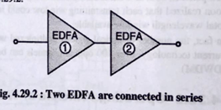

* In parallel combination, shown in Fig.; the demultiplexer is used to divide incoming signal into two wavelength bands (C and L).
* These two bands are applied to the corresponding optical amplifiers. At the output of each optical amplifier; Gain Flattening Filter (GFF) is used to equalize the gains. These two spectral bands are then combined using wideband multiplexer.
* Sometimes it is required to use both series and parallel combination together. It is called as hybrid combination.

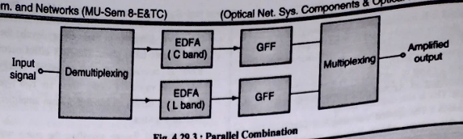

**Application**:

* Broadband optical communication systems, particularly in dense WDM networks.
* High Speed Internet Backbone

**Advantages:**

* **Wide Bandwidth:** Amplify signals across a broad spectrum of wavelengths, facilitating transmission of multiple channels simultaneously.
* **Scalability**: Support for high-channel-count WDM systems without requiring complex cascade configurations.
* **Low Noise Figure**: Maintain low noise figure across the entire amplification bandwidth, ensuring signal quality.
* **Compatibility**: Compatible with existing optical fibers and components, making them easy to integrate into existing network infrastructure.

1. **Write short note on optical isolator and circulator.**

* **Isolators,** main function is to allow transmission in one direction through it but block all transmission in the other direction.
* Isolators are used in systems at the output of optical amplifiers and lasers primarily to prevent reflections from entering these devices, which would otherwise degrade their performance.
* The two key parameters of an isolator are its **insertion loss**, which is the loss in the forward direction and which should be as small as possible, and its **isolation loss**, which is the loss in the reverse direction and which should be as large as possible

**Working**

* An optical isoiator includes three main components namely a
  + Faraday rotator,
  + input polarizer, &
  + an output polarizer
* The block diagram representation is shown Fig. 4.7.1. The working of this is like when light passes through the input polarizer in the forward direction & turn into polarized within
* the vertical plane.
* The operation modes of this isolator are classified into two types based on the different directions of light such as forward mode & backward mode.

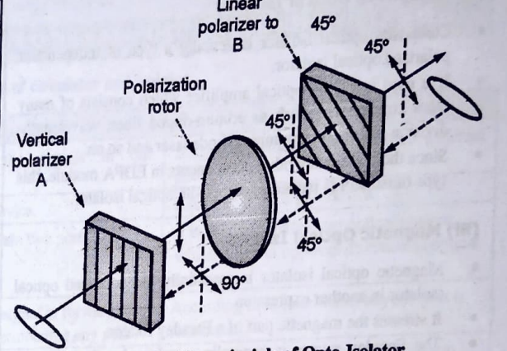

* The forward mode enables light enter into the input polarizer and become linearly polarized. When laser light reaches the Faraday rotator, the Faraday rotator rod will rotate by 45° polarization. Thus, the light finally leaves the output polarizer at 45° polarization. Shown in Fig. 4.7.2.
* However in the backward mode, the light first enters into the output polarizer with a 45° polarization. Next, as it passes through the Faraday rotator, it continues to be rotated for another 45° in the same direction. Then the light of 90° polarization becomes vertical to the input polarizer and cannot leave the isolator. As a result, the light will be either reflected or absorbed.

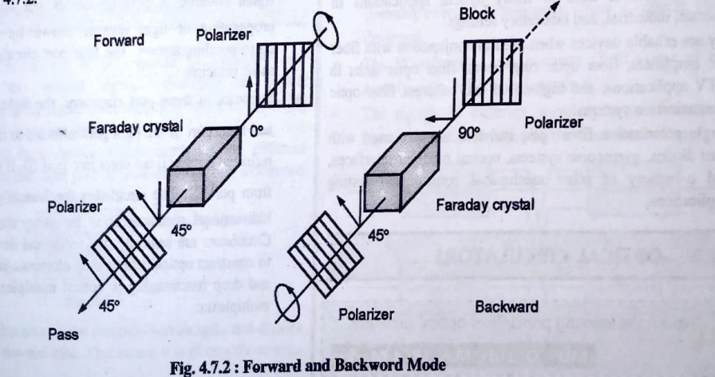

* A **circulator** is similar to an isolator, except that it has multiple ports, typically three or four.
* In a three-port circulator, an input signal on port 1 is sent out on port 2, an input signal on port 2 is sent out on port 3, and an input signal on port 3 is sent out on port 1.
* Suppose, in three port circulator, the light enters in port 1 and from port 2 the light gets reflected to the circulator ; then reflected light will not enter into port 1. It will be emitted out from port 3.
* Circulators are useful to construct optical add/drop elements.
* Circulators operate on the same principles as isolators.

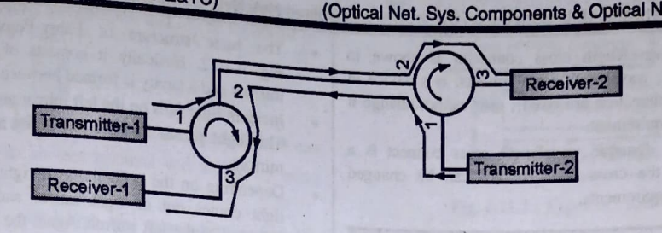

* As shown in the Fig, 4.8.2. signal from left to right is transmitted through two circulators having 3 ports and signal from right to left marked in blue is transmitted in the other direction over the same fiber optic cable.
* This forms the bidirectional link using circulators. From the fig.4.8.2.it is derived that port-1 acts as INPUT port, port-3 as OUTPUT port and port-2 as both INPUT/OUTPUT port.
* Hence transmitter-1 and 2 can transmit signal with wavelength 1550 nm on port 1 simultaneously and the same can be received on the respective other sides on port-3. Optical circulators are widely used in fiber amplification systems, WDM networks, OTDRs (optical time-domain reflectometers), covering unidirectional optical link to the bidirectional link and test and measurement instruments.

1. **Compare isolators and circulators**

|  |  |  |  |
| --- | --- | --- | --- |
| **Sr. No.** | **Parameters** | **Isolator** | **Circulator** |
| 1 | Direction | Transmits signals in one direction only. | Transmits signals between different ports. |
| 2 | Port | It is a two-port device. | It is a three or four-port device. |
| 3 | Usage | Used to isolate two ports. | Used to separate out optical powers in opposite directions in an optical cable. |
| 4 | Port Termination | Transmits the signal in forward direction without terminating any port. | According to requirements, any one port is terminated. |
| 5 | Application | Used to avoid reflected light entering the source. | Used to construct optical add or drop elements. |

1. **SONET architecture**

SONET stands for Synchronous Optical Network. It is a communication protocol, developed by Bellcore which is used to transmit a large amount of data over relatively larger distances by using optical fiber. By SONET, multiple digital data streams are transferred at the same time over the optical fiber.

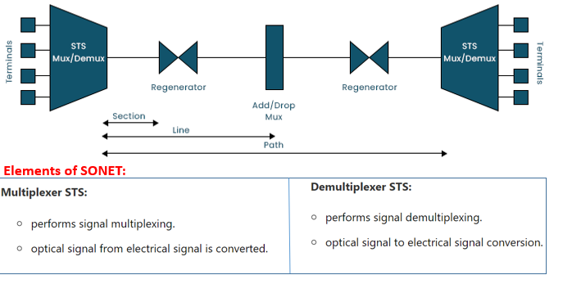

There are three basic SONET devices :

1. Synchronous Transport Signal (STS) multiplexers.

2. Regenerators.

3. Add/drop multiplexers.

**Operation of SONET devices**

* The STS Multiplexer/Demultiplexer is used for two purposes. It multiplexes signals from various sources into an STS i.e. Synchronous Transport Signal, or it demultiplexes an STS signal into various destination signals.
* Multiplexer and demultiplexer converts electrical signal to optical signal and optical signal back to electrical signal.
* The STS signal passes through a number of regenerators or repeaters while travelling from the source to destination. This repeaters regenerates or increase the strength of the signal.
* The regenerators are basically repeaters and are bidirectional devices. They will regenerate the STS applied to them. This will eliminate any effect of additive noise on the quality of transmission.
* The SONET regenerators function at the data link layer. The add/drop multiplexer is capable of adding signals from various sources or it can remove any signal and redirect it without demultiplexing the entire multiplexed signal.

**SONET CONNECTIONS/ HIERARCHY/LAYERS**

1. **Section Layer**

* It is responsible for the movement of signal across a physical section. Each device of network provides section layer functions.
* A section is a single fiber run that can be terminated by a network element (Line or Path) or an optical regenerator. The main function of the section layer is to properly format the SONET frames, and to convert the electrical signals to optical signals.
* Section Terminating Equipment (STE) can originate, access, modify, or terminate the section header overhead. (A standard STS-1 frame is nine rows by 90 bytes. The first three bytes of each row comprise the Section and Line header overhead.)

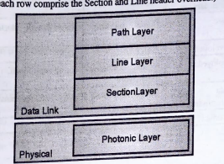

1. **Line**

* It is responsible for the movement of signal across a physical line. STS Mux/Demux and Add/Drop Mux provides Line layer functions
  + Line-Terminating Equipment (LTE) originates or terminates one or more sections of a line signal. The LTE does the synchronization and multiplexing of information on SONET frames.
* Multiple lower-level SONET signals can be mixed together to form higher-level SONET signals. An Add/Drop Multiplexer (ADM) is an example of LTE.

1. **Path**

* It is responsible for the movement of signals from its optical source to its optical destination.
* STS Mux/Demux provides path layer functions.
* Path-Terminating Equipment (PTE) interfaces non-SONET equipment to the SONET network.
* At this layer, the payload is mapped and demapped into the SONET frame.
* For example, an STS PTE can assemble 25 1.544 Mbps DS1 signals and insert path overhead to form an STS-1 signal.
* This layer is concerned with end-to-end transport of data.

1. **Photonic Layer**

* It corresponds to the physical layer of the OSI model.
* It includes physical specifications for the optical fibre channel (presence of light = 1 and absence of light = 0).

**SONET FRAME**

Fig. shows the SONET frame. It is basically a matrix of nine rows of 90 octets each. Thus the total number of octets is = 810 octets. The first three columns i.e. 3 x9= 27 octets are reserved for the administration overhead.

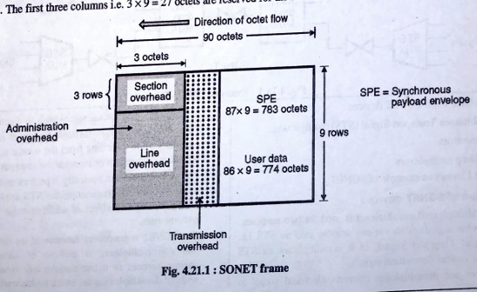

The remaining frame area 1.e. 87 x 9 = 783 octets is called as Synchronous Payload Envelope (SPE). The SPE is made of transmission overhead and user data. The administration overhead section is divided into two subsections namely section overhead and line

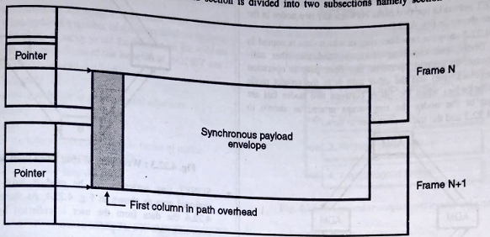

1. **Find the data rate of an STS-1 signal. (2M)**

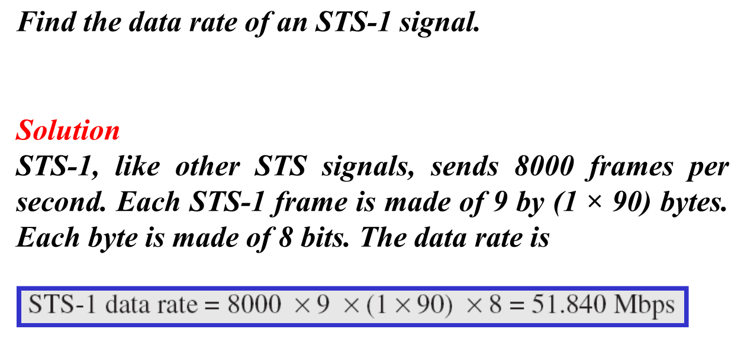

1. **Explain protection schemes in SONET/SDH.**

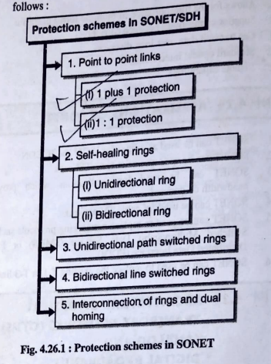

1. **Point to Point Links**

As the name indicates; this technique is applicable for providing a network protection in case of point to point communications. The two major types of point to point link protections are :

**1 plus 1 protection**

This type of protection scheme

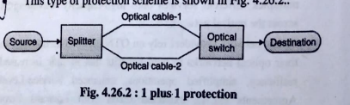

* Usually, in optical communication, one fiber optic link is used to transmit the data. But for protection purpose, one more optical cable is connected in parallel with working cable.
* The incoming data from source is applied to the splitter, which splits the same data on both fibers. In case of unidirection data transmission; the destination is connected to one of the fibers. But if there is failure in that cable then, using optical switch, the destination gets connected to another fiber cable.
* In case of bidirectional data transmission, two cables are connected between source and destination. So, for the protection purpose, two more optical cables are used.

**1 : 1 protection**

* As the name indicates, one protecting cable is used for one main optical cable, that means like 1 plus 1 protection, there are two optical cables between source and destination. But in this case, the data transmission takes place only through one fixed cable. It is called as working cable.
* If there is a failure then only the communication takes place using another optical cable, called as protecting cable.

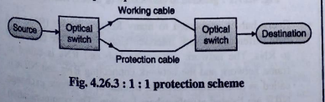

1. **Self-healing rings**

* Due to simplicity, ring networks are commonly used in optical communication. In this case, the protections are provided using SONET/SDH and Add or Drop Multiplexers (ADMs).
* The protecting rings are called as self-healing rings. Because such ring structure automatically detects the failure and transfer the data traffic in another route. Two types of such self-healing ring structures are used:

**(I) Unidirectional ring**

* In this case the working traffic is carried away in clockwise direction and protection is provided in anticlockwise direction.
* The working connection is shown by solid line and the protection connection is shown by dotted line in Fig.
* Here the working connection from node 1 to node 2 is in clockwise direction; similarly the working connection from node 2 to node 1 is also clockwise using another fiber.
* The protecting fibers are connected in anticlockwise directions. Likewise all the node are connected in a ring topology.

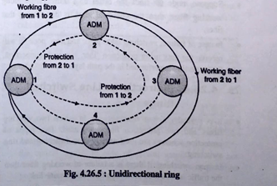

**(II) Bidirectional ring**

* In this case, the bidirectional data transmission takes place shown in Fig.
* The working fiber from node 1 to node 2 is connected in clockwise direction. While the working fiber from node 2 to node 1 is in anticlockwise direction.
* Similarly the protecting fibers are also bidirectional. It is a four fiber bidirectional line switched ring structure, which contains two working fibers and two protection fibers.

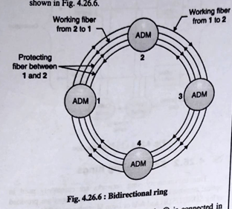

1. **Unidirectional Path Switched Rings**

* It is similar to one plus one protection scheme. Here the traffic is carried away simultaneously on working fiber in clockwise direction and the protection fiber in anticlockwise direction.
* Consider the communication between nodes 1 and 2. Initially node 2, checks the better connection on both fibers, working fiber as well as protection fiber.
* Suppose, node 1 finds the better data transmission along working fiber, then the communication is done using that fiber.
* In case of failure; switching takes place and now node 2 will receive the data using protection fiber. For each connection, the protection is performed in the path layer.

1. **Bidirectional Line Switched Rings**

* It is basically a four fiber network in which two working fibers and two protection fibers are used. Two types of protection schemes are used namely span switching and ring switching.
* In span switching, if there is a failure of working fiber then the traffic is routed on protection fiber on the same link.
* In case of ring switching; during the failure, the traffic is routed around the ring through the protecting link and it follows another path.

1. **Interconnection of Rings and Dual Homing**

* In case of bigger optical networks; one ring is not sufficient. The different rings are interconnected to each other.
* The simple type of interconnection is the connections of drop sides of ADM, on different rings. That means connection of two rings in a back to back fashion. But if the failure of any one ADM occurs then the entire interconnection is failed.
* This problem is avoided using a dual homing technique. Here two hub nodes are used between the rings to be interconnected. In case of failure, the connections can be transferred from one hub node to another.

1. **Compare SONET and SDH networks with PDH**

|  |  |  |
| --- | --- | --- |
| **Basis for Comparison** | **SONET** | **SDH** |
| Basic | Digital hierarchy interface | Network node interface |
| Developed by | ITU-T | ANSI |
| Deployed in | North America extensively | Europe and Japan |
| Data transmission | Only synchronous | Both synchronous and Asynchronous transfer is also possible |
| Overhead | 27 bytes | 81 bytes |
| Full- form | SONET stands for Synchronous  Optical Network. | SDH stands for Synchronous Digital  Hierarchy. |
|  | It does not provides better  transmission rates as compared  to SDH. | It provides better transmission  rates as compared to SONET. |

1. **What is WDM? Explain the architecture of WDM with network components. Explain Two-level hierarchy in WDM Metro Network?**

# Wavelength Division Multiplexing

* In WDM, two or more optical signals with different wavelengths are combined and simultaneously transmitted in the same direction over an optical fiber. WDM technology is independent of rate and format, and it can support any combination of interface rates.
* This schematic of wavelength division multiplexing is as shown in Fig. Here a number of light sources are used. Each light source emits the light of different wavelength. As an example three light sources emits the three wavelengths of light as shown in Fig. Optical multiplexer is used at the input side to multiplex these signals.

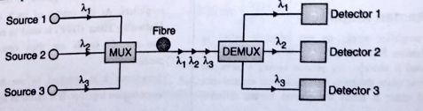

* Now this multiplexed signal is transmitted by using optical fiber. The detector is not capable of separating these signals. So a demultiplexer is used at the output side to differentiate the signals of equal amplitude. An improved version of this type of multiplexing is the bidirectional wavelength division multiplexing. The schematic of this type is as shown in below Fig.
* Here for the light sources 1 and 2 the first device (MUX / DEMUX1) as multiplexer and the second device (MUX / DEMUX2) act as demultiplexer. Thus the signals gets transferred from sources 1 and 2 to the detectors 1 and 2. Now while transferring the signals from sources 3 and 4 to detectors 3 and 4 the reverse case takes place. Thus a bidirectional data transmission is done.

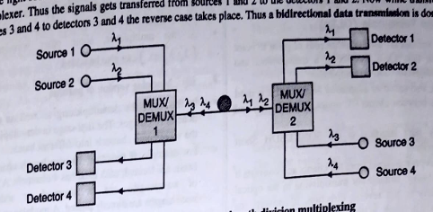

**WDM ARCHITECTURE**

The general architecture of wavelength routing mesh network is shown in Fig. The different WDM network elements like Optical Line Terminals (OLT), Optical Add Drop Multiplexer (OADM), Optical Cross Connects (OXC) etc. are shown in the architecture.

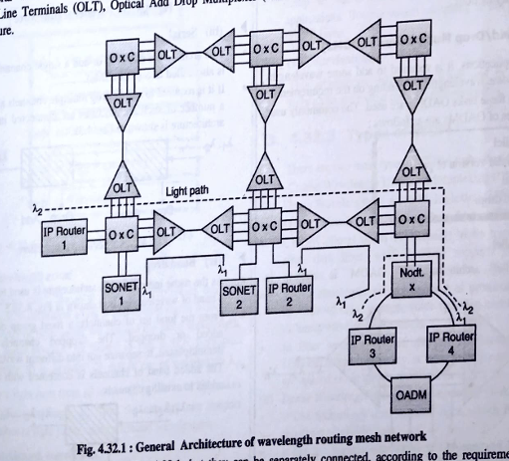

Optical amplifiers are not shown in Fig; but they can be separately connected, according to the requirements or optical amplifiers can be inbuilt in OLT, OADM or OXC. The users such as SONET boxes and IP routers are connected using different light paths as shown in Fig. In a light path, at some places, it is required to change the wavelength of operation. For this wavelength converters are used. In Fig, operating wavelength λ1 is shown by a solid line and wavelength λ2 is shown by dotted line.

**WDM NETWORK ELEMENT**

1. **Optical Line Terminals (OLTs)**

* Optical line terminals are used at either ends of point to point communication link. OLT consists of a transponders and wavelength multiplexers and demultiplexers.
* Transponder is also called as adaptation device and it is used as an interface between clients (IP router, SONET etc.) and optical link.
* The commonly used interface is the SONET/SDH Short Reach (SR) interface.
* Transponder accepts the signal from the clients and converts it into the form which is suitable for transmission in the optical network. Similarly in the reverse direction, it converts the signal from optical network, in the form suitable for clients.
* The signal output from transponder is multiplexed with other signals of different wavelength, using wavelength multiplexer.
* In some cases, optical amplifiers are used to boost these signals. At the other end, using demultiplexer, the signal of required wavelength is extracted.
* The output of OLT is also terminated on Optical Supervisory Channel (OSC). The OSCs operate on different wavelength than actual traffic.
* The OSC signals are used to monitor the performance of optical amplifiers, as well as to perform some other management functions.

2. **Optical Add/Drop Multiplexers (OADMs)**

* In some applications, it is required to add some wavelengths or to drop some wavelengths; depending on the requirements.
* To perform these tasks OADMs are used. The commonly used architectures of OADMs are as follows :
  + Parallel
  + Modular version of parallel
  + Serial
  + Band drop.

**Parallel:**

The parallel architecture of OADM is shown in fig.

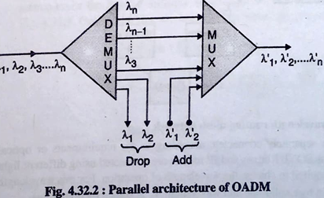

* Initially all incoming channels are demultiplexed to generate separate output wavelengths λ1, λ2 ....
* Some of the wavelengths are dropped at this stage and other wavelengths channels are passed forward to the multiplexer.
* At the multiplexer, some other wavelength channels (λ`1, λ`2 etc. ) can also be added.

**Modular version of parallel**

* In this case, the demultiplexing as well as multiplexing is done in two stages. The first stage in demultiplexing separates the wavelength channels into different bands.
* For example, if there are 16 wavelength channels then four bands are formed; each band has 4 channels. A particular band of wavelengths can be dropped or added; remaining wavelengths are directly passed. A modular version of parallel architecture is shown in Fig.

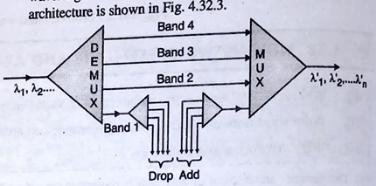

**Serial**

* This architecture can drop or add a single channel at a time. It is also called as S (- OADMs).
* If it is required to add or drop multiple channels at a time then, a number of such architectures are connected in series. This architecture is shown in Fig.

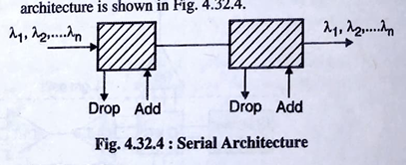

**Band drop**

* As the name indicates; this architecture is used to drop or add a band of wavelengths. It is shown in Fig.
* From the total set of channels; a fixed group of channels is added or dropped. The dropped channels are again demultiplexed, to separate out into different wavelengths.
* The added band of channels is combined with couplers and added to existing channels.

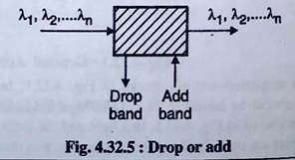

**3. Optical Cross Connects (OXC)**

* Whenever there is large amount of traffic at any node in optical network or there are many optical nodes in the complex network then optical cross connects are used to smooth out the operations.
* OXCs work along with OLTs, SONET/SDH, OADMs etc. In a larger networks, OXCs are

used to provide extra light paths automatically. As well as OXCs can be used to reconfigure the existing light paths. In case of fiber cut or failure of optical element; OXC is used to detect such things and then to provide an alternate light path.

* The test equipments can be connected to the test ports, where the signals which are passing through OXCs can be monitored.
* OXCs can also be used to switch the optical signals from one port to another port and it also provides the wavelength conversion, if required.
* OXCs contain multiplexing capabilities to switch the traffic internally.

**Benefits of WDM System:**

* Capacity upgrade: WDM facilitates enhancing the capacity of current point-to-point fiber optic transmission links.
* Transparency: WDM enables the transmission of data in various formats, including asynchronous and synchronous digital data, as well as analog information, along the light path.
* Wavelength Reuse: WDM allows multiple light paths within the network to share the same wavelength, provided they don't overlap on other links, enhancing efficiency.
* Wavelength routing: With WDM, data can be directed along specific paths based on the wavelength of the light signal, optimizing network traffic.
* Wavelength converting: WDM technology allows for the conversion of signals from one wavelength to another, enhancing flexibility and compatibility within the network infrastructure.

1. **What is DWDM. Mention its advantages and disadvantages**

In the Dense Wavelength Division Multiplexing(DWDM), the channels which are used to carry different wavelengths are very close (dense) to each other.

**What is the Necessity of DWDM**

* In case of optical communication, attenuation and dispersion are the major problems. It limits the practical speed and the distance of communication.
* Using Erbium Dopped Fiber Amplifier (EDFA), the problem of attenuation of signal can be recovered. However, due to the bandwidth effect always a compromise is required between transmission distance and the bandwidth.
* So, repeaters are used, after a certain distance, all along the length of optical cable. This increases the total cost of system. DWDM increases the bandwidth of systems, without using the repeaters.
* EDFA are commonly operated in the range of wavelengths 1525 nm to 1565 nm and DWDM are used in the band of 1550 nm. So, DWDM increases the capabilities of EDFA.
* In order to implement 100 Gbps networks; there is a requirement of faster physical layer technology. The normal optical networks are not capable of supporting this bandwidth for more than 500 meters distance. The DWDM increases the bandwidth and it supports for more transmission distance.

**DWDM SYSTEM STRUCTURE**

The DWDM system structure consists of following components :

* **Laser transmitters:** The different laser sources transmitting laser beams at accurate wavelengths. Each laser source, transmits different wavelength and all wavelengths from individual laser sources are closely spaced.
* **Receivers:** These are optical detectors, which receives the signal and transmit them into demultiplexers.
* **Eribium dopped fiber amplifier (EDFA):** It is eribium dopped fiber amplifier. It is a silica based optical fiber and it is dopped with eribium. Basically EDFA acts as a repeater and it is used to amplify incoming optical signal.
* **OADM:** These are the components receiving an optically multiplexed signal and can add or drop a certain wavelength.
* **DWDM MUX:** It is DWDM multiplexer, which receives many optical signals of different wavelengths; and transmits € them on a single optical cable.
* **DWDM DEMUX:**

1. It receives all the signals on a single cable and transmit each wavelength on different cables. The DWDM system structure is shown in Fig.

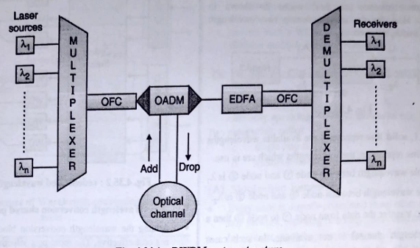

1. The laser sources, transmit different wavelengths. All these wavelengths are applied to the multiplexer. The different fibers carry these wavelengths to the multiplexer. The multiplexers, combine all these wavelength and transmit it on a single Optical Fiber Cable (OFC).
2. OADM can take certain wavelengths of its channel or add certain wavelength from other optical channel. It can also drops certain wavelength from main optical cable to other optical channels.
3. EDFA is used to amplify the signals. The output of EDFA is connected to demultiplexer which separates out the different wavelengths.

There are two types of DWDM network as follows :

1. **Single hop networks:** In this case each data stream has same wavelength from source to destination.
2. **Multiple hop networks:** Whenever there is an overlapping of network paths (light paths) the reuse of wavelength is done. Each node has a limited number of wavelengths, so at intermediate nodes, electronic switching of packets is required.

**Advantages of DWDM**

* DWDM increases the bandwidth capacity of the channel.
* Using DWDM, it is possible to use signals with different data rates and different formats.
* A large amount of information can be transmitted simultaneously.
* DWDM can handle higher data rates.
* Every wavelength is independent of others
* Optical amplifier can act on all wavelengths, providing cost savings over a single amplifier per fiber.
* The capability to support 160 wavelengths means that over 1Tbps of traffic can be used.
* Each wavelength can be a different traffic type such as SONET, gigabit, Ethernet or IP can be operated at different speeds.
* This provides Bandwidth and protocol flexibility with payload efficiency.

**Disadvantages of DWDM**

* Some fiber plants are not suitable for DWDM Vendor Inter-operability issues exist
* DWDM systems can be extremely difficult to troubleshoot, manage and provision.
* Service providers typically run SONET over DWDM to utilize SONETS's network management capabilities but DWDM equipment's need to be managed.
* Not cost effective for low channel numbers
* Complex technology requires.
* More space and More power.
* Startup cost more than equivalent CWDM.
* High accuracy laser and wave filter.

**Explain Two-level hierarchy in WDM Metro Network?**

* The metro network can be broken up into two parts :

1. The first part is the metro access network and extends from the carrier's central office to the carrier's customer locations, serving to collect traffic from them into the carrier's network.
2. The second part of this network is the metro interoffice network-the part of the network between carrier central offices.

* The access network today typically consists of rings a fewnkilometers to a few tens of kilometers in diameter, and traffic is primarily hubbed into the central office.
* The interoffice network tends to be several to a few tens of kilometers between sites, and traffic tends to be more distributed. Because of the shorter spans involved, the case for WDM links is less compelling in metro networks. The other alternatives, namely, using multiple fibers or using higher- speed TDM, are quite viable in many situations.
* Metro carriers need to provide a variety of different types of connections to their customers. The service mix includes leased private-line services and statistical multiplexing types of services such as IP, Ethernet, Gigabit Ethernet, and Fibre Channel.
* In many cases, this service mix is supported by having a set of overlay networks, each dedicated to supporting a different service. These overlay networks are ideally realized using a single infrastructure. Because of its transparent nature, a WDM network provides a better infrastructure than most others, such as SONET/SDH, for this purpose. Another factor is that the traffic distribution changes much more rapidly in metro networks than in long-haul networks.
* This drives the need to be able to rearrange network capacity quickly and efficiently as needed. Reconfigurable WDM networks allow capacity to be provided as needed in an efficient manner.
* A big driver for WDM deployment in metro networks has been the need for large enterprises to interconnect their data centers. These data centers are separated by several kilometers to a few tens of kilometers. All transactions are mirrored at both sites. This allows the enterprise to recover quickly from a disaster when one of the centers fails. There may be other reasons to have separate data centers, such as lower real estate costs at one location than at the other. Peripheral equipment such as disk farms can be placed at the cheaper site. The bandwidth requirement for such applications is large.
* The large mainframes at these data centers need to be interconnected by several hundred channels, each up to several gigabits per second.
* Typically, these data centers tend to be located in dense metropolitan areas where most of the installed fiber is already in use. Moreover, these networks use a large variety of protocols and bit rates. These two factors make WDM an attractive option for these types of networks.
* These networks are sometimes called storage-area networks. This is the primary application for most of the WDM networks deployed in metro networks today.
* Because of the nature of the traffic and a large amount of pass through traffic in these networks, a strong case can be made for deploying WDM rings with optical add/drop multiplexers instead of higher-speed TDM rings.
* Despite the shorter spans for metro networks, optical ampliflers may still be needed, for several reasons:

1. Although spans are short, in many cases the fiber in the ground is old, has many connectors in its path, and thus has relatively high loss. For example, a 10 km metro link may have a loss as high as 10 dB.
2. The loss is not just due to spans a large component of the loss comes from the loss of optical add/drop multiplexers, each of which can add several decibels of loss.
3. Finally, protection requirements drive the need for alternate spans that may be much longer (for example, around a ring) than the working spans.
4. **What is OTN(2M)**

A set of Optical Network Elements connected by optical fiber links, able to provide functionality of transport, multiplexing, switching, management, supervision and survivability of optical channels carrying client signals.

OTN is used because of following reasons;

* + - Operators’ need to use existing fiber to satisfy Growing demand for services and bandwidth.
    - DWDM increased fiber bandwidth, but lacked protection and management capabilities.
    - OTN combines the benefits of SONET/SDH with DWDM.

Figure shows the format of the synchronous OTN frame.

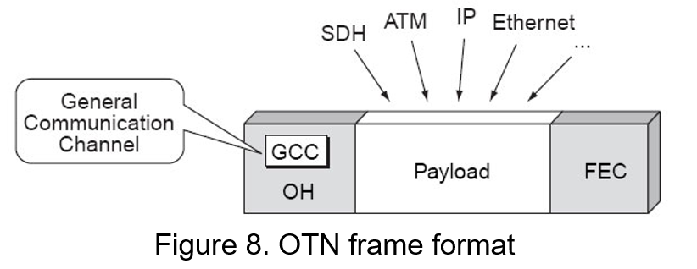

All types of frames are to be transported transparently in the OTM frame, without them having to be modified. A field is expected to add an FEC (Forward Error Correction) to perform the necessary corrections to achieve an error rate determined.

OTN interface consists of several levels. Starting from the optical fiber with the following layers are:

1. OTS (Optical Transmission Section), which supports signal transmission optical checking its integrity.
2. OMS (Optical Multiplex Section), which supports features to provide a wavelength-division multiplexing.
3. OCH (Optical Channel), which is the level of one end of the optical signal. This level allows modification of the connection and rerouting, and maintenance functions to the connection.
4. In order to get access for end-to-end networking of optical channels to transparently convey user information, the OCh layer is employed in the OTN structure. It also ensures connection rearrangement for flexible routing. Either full or reduced optical channel availability can be employed as required.
5. DW (Digital Wrapper), which corresponds to the digital envelope. The level Digital Wrapper itself is broken down into three levels:
6. OTU (Optical Transport Unit), which gives the possibility of adopting a correction using FEC.
7. The OTU layer gives additional functionality by adding forward error correction to the network elements and by allowing carrier operators to reduce the number of optical devices and switches used in the network (i.e. amplifiers, multiplexers, 3R regenerators). It also encapsulates two additional layers, the optical channel data unit (ODU) and the optical channel payload unit (OPU).
8. ODU (Optical Data Unit), which manages connectivity regardless of clients and offers protection and management of this connectivity. The ODU layer provides client-independent connectivity, connection protection and monitoring whereas the OPU enables access to the payload information of SDH/SONET signals.
9. OPU (Optical Payload Unit), which indicates a match between the signal and the type of client. The overall architecture of OTN is shown in Figure.

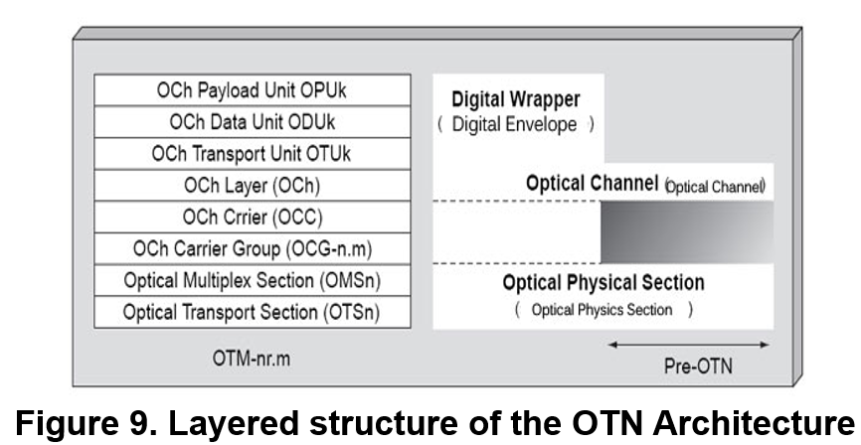

1. The OTN hierarchy to support these four layers may also include three sections as, which are: the optical transmission section (OTS); the optical multiplexing section (OMS); the optical physical section (OPS).
2. Different physical sections of the OTN are interfaced based on the information obtained from OTS, OMS and OPS, respectively.
3. OTS provides the required information about optical transmission functionality for optical signals to travel through optical fibers and the necessary switching operation at fiber end points.
4. The optical multiplexing section (OMS) gives the means of networking for a multiwavelength optical signal, whereas the OPS describe the optical characteristics of the physical section in order to provide reduced functionality excluding those sections which are not required to establish an interface between two domains.

**Advantages:**

* Protocol transparency, Integrity of the client signal is maintained, end user views exactly what was transmitted.
* Backward compatibility for existing protocols.
* Better switching scalability, OTN is able to switch at a higher bit rates than SDH.
* Better Forward Error Correction (FEC).

1. **Explain the advantages of OTN over SONET**

* The OTN architecture concept was developed by the ITU-T initially a decade ago, to build upon the Synchronous Digital Hierarchy (SDH) and Dense Wavelength-Division Multiplexing (DWDM) experience and provide bit rate efficiency, resiliency and management at high capacity. OTN therefore looks a lot like Synchronous Optical Networking (SONET) / SDH in structure, with less overhead and more management features.
* It is a common misconception that OTN is just SDH with a few insignificant changes. Although the multiplexing structure and terminology look the same, the changes in OTN have a great impact on its use in, for example, a multi-vendor, multi-domain environment. OTN was created to be a carrier technology, which is why emphasis was put on enhancing transparency, reach, scalability and monitoring of signals carried over large distances and through several administrative and vendor domains.

**Advantages of OTN compared to SDH/SONET**

**Better scalability**

The old transport technologies like SONET/SDH were created to carry voice circuits, which is why the granularity was very dense-down to 1.5 Mb/s. OTN is designed to carry a payload of greater bulk, which is why the granularity is coarser and the multiplexing structure less complicated.

**Better Forward Error Correction:**

* OTN has increased the number of bytes reserved for Forward Error Correction (FEC), allowing a theoretical improvement of the signal-to-Noise Ratio (SNR) by 6.2 dB. This improvement can be used to enhance the optical systems in the following areas.
* **Increase** the reach of optical systems by increasing span length or increasing the number of spans.
* **Increase** the number of channels in the optical systems, as the required power theoretical has been lowered 6.2 dB, thus also reducing the non- linear effects, which are dependent on the total power in the system.
* **The increased** power budget can ease the introduction of transparent optical network elements, which can't be introduced without a penalty. These elements include Optical Add-Drop Multiplexers (OADMs), Photonic Cross Connects (PXCs), splitters, etc., which are fundamental for the evolution from point-to-point optical networks to meshed ones.
* **The FEC part** of OTN has been utilised on the line side of DWDM transponders for at least the last 5 years, allowing a significant increase in reach/capacity.

**Transparent Client Signals**

In OTN the Optical Channel Payload Unit-k (OPUk) container is defined to include the entire SONET/SDH and Ethernet signal, including associated overhead bytes, which is why no modification of the overhead is required when transporting through OTN. This allows the end user to view exactly what was transmitted at the far end and decreases the complexity of troubleshooting as transport and client protocols aren't the same technology.

* **Standard Hierarchy :** OTN standards include a standard multiplexing hierarchy, defining exactly how the lower-rate signals ascend into the higher-rate payloads. This allows the WDM platform to shift lower-rate services within 10Gbps, 40Gbps, or 100Gbps wavelengths, without the need for external wavelength demultiplexing and manual interconnects.
* **Transport Capacity Expansion :** OTN networks provide the underlying high-capacity infrastructure for core interoffice, metropolitan interoffice, and broadband business-access networks. Carriers deploy OTN to support the greatest number of services on the least amount of infrastructure.
* **Reduced Cost :** With multiple clients transported on a single wavelength and their specific requirements preserved, OTN network reduces the overall cost of transport and ensures efficient bandwidth utilization.
* **Transport Flexibility :** Network operators can employ the technologies needed to support current transport demands, while also enabling future adoption of new technologies as business needs dictate. It can easily scale to ring networks, end to end networks and mesh networks.
* **Timing Transparency :** Timing transparency is important for offering wholesale services for third-party providers. The transparency of OTN enables the networks to carry any service, including Ethernet, storage, digital video, as well as SONET/SDH without interfering with the client timing.

1. **What is fiber bragg gratings, Grating principle? Give its applications**

* Basically grating means a series of grooves are formed such that a particular wavelength of light is reflected and other wavelengths are transmitted.
* These grooves can be formed inside the optical cable. It is also called as grating are written in fibers. The gratings are written in the fiber by making use of photosensitivity property of the fiber. Generally fiber is made using silica material. When it is dopped using germanium then it becomes photosensitive.
* When UV (ultraviolet) rays falls on this fiber then the refractive index of core layer is changed. By this way gratings can be written inside the fiber.
* Two UV beams are used to illuminate the fiber core ; then the radiation intensity varies periodically along the length of optical cable. For the low radiation intensity ; the refractive index is unchanged and when the radiation intensity is high the refractive index is increased.

Types of Fiber Grating:

**1. Fiber Brag Grating (FBG):**

* It is also called as distributed brag reflector and it is constructed in the short length of optical cable. This grating has a property to reflect a particular wavelength and to pass all remaining wavelengths. This property can be achieved by making the variations in the refractive index of fiber core.
* Consider a fiber brag grating used along with a circulator as shown in Fig.

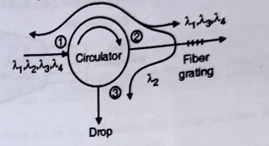

* This is three port circulator. If input is applied to port 1 then output is generated to port 2 and if input is applied to port 2, then output is generated at port 3.
* Suppose the wavelengths λ1, λ2, λ3 and λ4 are applied to port 1 and λ1, λ3, λ4, are the required wavelengths. Basically circulator passes these all wavelengths to port 2.
* The fiber grating is placed at port 2 and it is designed in such a way that; the wavelength λ2 gets reflected by this grating. This reflected wavelength will be routed to port 3.
* This is basically called as optical drop element because the wavelength λ2 is dropped. After the diffraction grating ; we can connect one more circulator and wavelength λ2 is again added. It will produce the outputs λ1, λ2, λ3 and λ4. This later part is called as optical add element. These short period grating is having a period around 0.5 um, which is comparable to the wavelength.

**2. Long Period Fiber Gratings**

* As the name indicates; the period of such grating is long. This period is much greater than wavelength. It is in terms of millimeter. These grating are fabricated using same technique as that of fiber brag grating. Now a days, these gratings are used as filters inside erbium dopped fiber amplifier.
* In case of short period fiber grating, the wavelength to be reflected is transferred (coupled) from forward mode to the backward mode. In long period fiber gratings, the required energy is coupled from the forward mode incore layer to another forward mode is cladding layer.
* Many losses take place in the cladding modes and their energy decreases as they propagate along the fiber.
* The coupling between core mode and a particular cladding mode depends on the pitch or grating.

**Advantages of Fiber Gratings**

(i) It possess very low losses because it is basically all fiber device.

(ii) Easily coupled with other fibers.

(iii) Fiber gratings are not sensitive to polarization.

(iv) They have low temperature coefficients.

1. Packaging is simple and cost is low.
2. **Write short note on optical switches, principle**

* An optical switch is a multi-port network bridge, which connects multiple optic fibers to each other and controls data packets routing between inputs and outputs. Some optical switches convert light to electrical data before forwarding it and converting it into a light signal again.
* Other optical switches, which are called All-optical, can route and forward the light pulses themselves without any electrical conversion. An optical switch is a device that can selectively switch light signals that run through in optical fibers or integrated optical circuits from one circuit to another.
* Optical switches can transfer light signals between different channels in communication networks. As the growing popularity of Internet and telephone, greater quantities of data managed by communication networks also expanded. Optical switching technology provides a perfect solution to fully exploit capacity of optical systems.

**Working Principles of Optical Switches**

* When a light signal runs through from one computer to another in fiber optic networks, it may be required to move the signal between different fiber paths. To accomplish this, a
* switch is required to transfer the signal with a minimum loss. Optical switch is a technology needed.
* The optical switch we often see is operated by mechanical method which just moves fiber or other bulk optic components. But they can offer unprecedented high stability and unmatched low cost performance.
* Optical switches are mainly deployed in establishing the light path. They feature scalability and highly reliable switching capacity.

**Major functions of optical switches:**

1. **Protection:** Sometimes a failure of some single point can cause the whole network breaking down. And the protection switching is to protect the transmission data, which can avoid network fault before finding the failure causes.
2. **Optical add/drop multiplexing:** Optical switches must be equipped with the capability that can add or delete the wave channels without any electronic processing. This kind of optical switches is also called wavelength selective switches.
3. **Optical spectral monitoring:** Optical spectral monitoring is a network management operations. In this process, operators receive a small portion of optically tapped signal for monitoring power level, wavelength accuracy and optical cross talk.

**Types of Optical Switches:**

1. Opto-Mechanical optical switches
2. MEMS (Micro-Electro-Mechanical-System)Switches
3. Liquid crystal switches
4. Electro-optic switches
5. Thermo-optic switches
6. Semiconductor optical amplifier switches
7. **Define four wave mixing**

* The term FWM refers to Four Wave Mixing. It also mentions effects of FWM and how to reduce it in optical fiber. Optical Four wave mixing is similar to **third order intermodulation distortion** seen in electronic or RF circuit.
* FWM is the short form of Four Wave Mixing. This term is given to the most common interference found in DWDM optical fiber systems. In DWDM, multiple optical signals of various different wavelengths are combined; it will form a new signal of undesired wavelength..
* The Fig. 4.16.4. depicts FWM effect in two channel WDM system on low dispersion fiber cable. The FWM effect usually occurs in nonlinear optical materials e.g. photonic switch, fiber cable etc. This interaction between waves will lead to interaction between the channels.

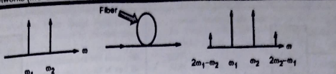

* As shown in Fig. , when two input signals located at W1 and W2 traverse fiber of length (L), it will produce outprits at four frequencies located at W1, W2, 2W1-W2 and 2W1. FWM depends on following parameters:

1. Dispersion
2. Effective Area
3. Channel spacing

* FWM can be expressed as follows:

FWM- {Power4 / (Dispersion2 x Effective Area2 x Channel Spacing4)}

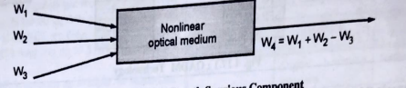

* The above Fig depicts generation of fourth wave when three channels are provided as input to the nonlinear fiber device or component. As shown it produces fourth component equal to w1 + w2 - w3.
* In general, when three waves at frequencies of fi, fj and fk traverse a fiber, they will generate another signal as defined by following equation.

Fa = fi + fj - fk Where i, j is not equal to k

* If there are N channels, the newly generated signals are expressed as follows.

M=(1/2)*N2*(N-1)

Where N = Number of input frequencies.

M= Mixing products generated at the output.

* If there are 3 channels, this will at additional signals. From this it can be observed that if N increases, M increases rapidly.

**Effects of FWM-Four Wave Mixing**

1. Four Wave Mixing is one of the most troublesome issue in optical domain. It produces unwanted spurious components which cause following problems.
2. Produces interference between wanted optical signals.
3. Produces additional noise which degrades the performance of the optical system.
4. Some power will be lost from wanted wavelengths to the unwanted ones.
5. As mentioned in above equation, if number of channel increases then mixing products at the output increases rapidly.
6. **Explain Arrayed Waveguide gratings? Mach Zender interferometer? How it differs from Optical directional coupler**

* Arrayed waveguide grating (AWG) consists of **two multiport couplers** interconnected by an **array of waveguides**.
* The AWG is a device where **several copies of the same signal**, but shifted in **phase by different amounts**, are added together.
* It can be used as an n × 1 wavelength multiplexer. It is an n-input, 1-output device,
* Where the n inputs combined onto the single output.
* The inverse of this function, namely, 1 × n wavelength demultiplexing, can also be performed using an AWG.
* An AWG has lower loss and flatter passband, and is easier to realize on an integrated-optic substrate.
* The input and output waveguides, the multiport couplers, and the arrayed waveguides are all fabricated on a single substrate.
* Thirty-two–channel AWGs are commercially available, and AWGs are being used in WDM transmission systems.

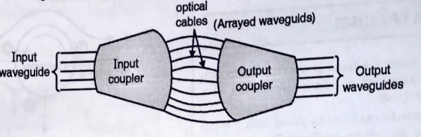

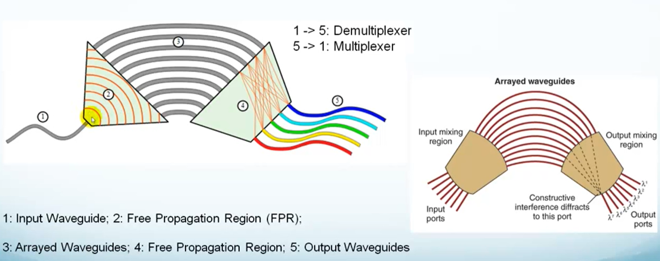

* It consists of two couplers, namely input coupler and output coupler. Let us say input coupler has 'n' input ports and 'm' output ports. While output coupler has 'm' input ports and 'n' output ports.
* These two couplers are connected by using 'm' number of optical fiber cables. These connecting cables are called as arrayed waveguides.
* All these components of AWG, namely input-output couplers along with input-output waveguides and the arrayed waveguides (optical fiber cables) ; all are fabricated on a single substrate.
* The substrate material is usually SiO2 or silica, Indium Phosphide (InP) etc. The incoming light traverses a free space or input waveguides and enters into input coupler.
* The input coupler couples these light rays to 'm' optical fibers. These fibers are called as arrayed waveguides and these fibers are having different lengths. Due to difference in length; every fiber produces different phase to incoming wavelength. All these signals from 'm' optical fibers are coupled to free space or output waveguides through output coupler.
* The signals passing through arrayed waveguides, interfere with the signals passing through the neighbouring arrayed waveguides. This interference can be constructive or destructive. So, depending on interference a signal of require wavelength can be obtained at the output device. When there are only two input ports and two output ports, then such AWG is called as Mach-Zehnder Interferrometer (MZI).

**How it differs from Optical directional coupler**

* Arrayed Waveguide Gratings (AWGs) and optical directional couplers serve distinct functions in optical communication systems. AWGs separate an input optical signal into its constituent wavelengths, utilizing interference effects in a series of waveguides, making them ideal for wavelength division multiplexing (WDM) and demultiplexing applications. Conversely, optical directional couplers enable the coupling of light between two or more waveguides, relying on evanescent coupling to split or combine optical signals. While AWGs are essential for multiplexing and demultiplexing multiple optical channels onto a single fiber, optical directional couplers find applications in power splitting, signal combining, and optical switching tasks within optical networks.

**Module 5**

1. **Explain Optical Burst Switching Networks. (2M)**

* It combines the best features of circuit and packet switching and hopefully - avoids the worst of both.
* A burst has two components:
  + - * Control
      * Payload
* The control packet carries the header information.
* Payload is the actual data transmitted.
* OBS :- control information is separated from the payload.

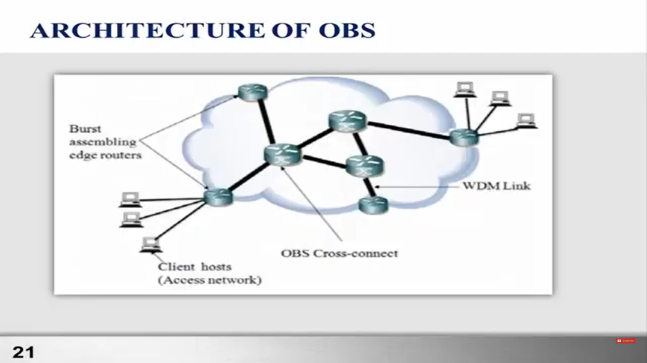

* OBS network having two types of nodes: 1 ) Edge node

2) Core node

* Edge nodes are at the interface between the electronic and optical domain. Edge nodes can be an ingress or egress node.
* Packets are assembled into bursts at ingress edge node, which are then routed through the OBS network and disassembled back into packets at egress edge node.
* core node which is responsible to forward data burst.
* A node in OBS network consists of both optical and electronic components.
* The optical components are multiplexers, demultiplexers and an optical switching network.
* The electronic components :-

1) Input modules (IM),

2) output module (OM),

3) control burst router (CBRT),

4) scheduler.

* Edge node transmit a data burst, it sends a control packet to core node.
* At core node, the control packet is input to the corresponding input modules (IM), which converts the control packet into electronic form.
* **Control fields** are extracted from the control packet.
  + The control burst router (CBRT) these control fields to determine thenext outgoing fiber for the corresponding payload.
* Scheduler selected outgoing link for Control packet and the control packet is buffered until the scheduled time.
* At Output module (OM) which updates its control fields and transmits it to the selected outgoing fiber using the optical transmitter.
* Just before the payload arrives, the switching element in the node is connect the input port to the corresponding output port.
* If the control packet is unable to reserve the wavelength then the control packet as well as payload is dropped.

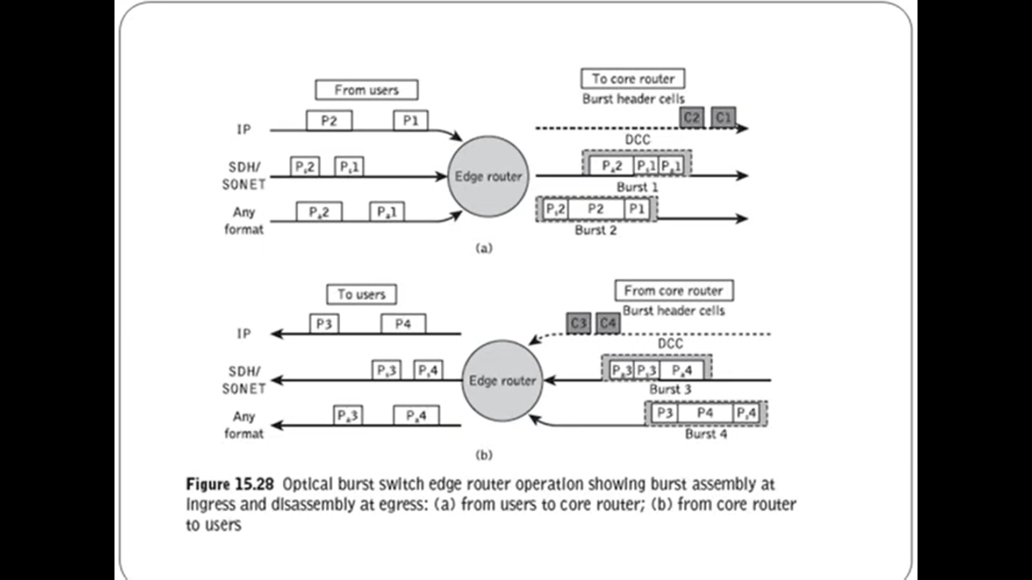

1. **Compare Optical Packet switching and Optical Burst Switching**

|  |  |  |
| --- | --- | --- |
| **Aspect** | **Optical Packet Switching (OPS)** | **Optical Burst Switching (OBS)** |
| Data Handling | Data divided into fixed-size packets | Data grouped into larger bursts |
| Switching Mechanism | Switches each packet individually | Switches entire bursts at a time |
| Contention Resolution | Contention resolved at packet level | Contention resolved at burst level |
| Complexity and Overhead | More complex buffering and scheduling | Lower complexity and overhead |
| Efficiency | Efficient for smaller data packets | Efficient for bursts with multiple packets |
| Latency | Higher latency due to packet-level processing | Lower latency due to burst-level switching |
| Overhead | Higher overhead due to individual packet processing | Lower overhead due to burst-level switching |

1. **Explain OTDM multiplexing and demultiplexing in detail. Explain OTDM. Explain bit interleaving and packet interleaving techniques used in OTDM**

**Optical Time Division Multiplexing OTDM**

Solution of WDM is OTDM (Optical Time Division Multiplexing) which is introduce in early 1990s.

## **Advantage of OTDM:**

* Flexible bandwidth
* Overcomes non-linear effect associated with WDM
* The total capacity of single-channel OTDM network is equal to DWDM
* Less complex end node equipment
* Can operate at both:
* 1550 nm (like WDM) due to EDFA
* 1300 nm
* Offers both broadcast and switched based networks

# Basic Principle of OTDM

* Indeed, Optical Time Division Multiplexing (OTDM) is a powerful optical multiplexing technique that combines multiple low bit rate channels into a single high bit rate channel based on time division. In OTDM, each channel is multiplexed into the multiplexer for a given period of time, allowing for efficient utilization of the optical fibers bandwidth and enabling high-speed data transmission.
* In OTDM, only one wavelength of light is used instead of Different wavelength of light in WDM.

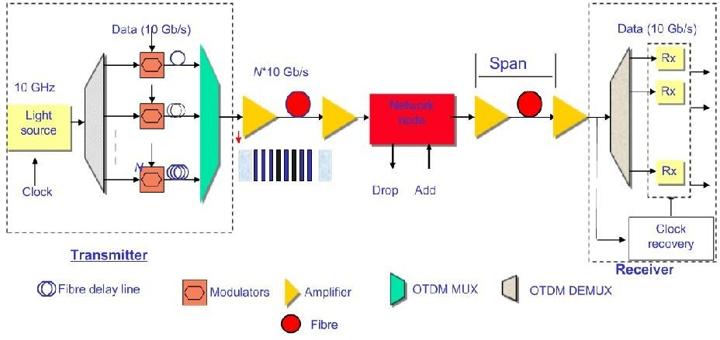

Figure 5.schematic Diagram of Basic principle of OTDM

### General Description

A Simple OTDM system consists of three stages:

1. Transmitter,
2. Inline system, and
3. Receiver.

* The Transmitter comprises an Optical source, Modulator, Channel alignment, and multiplexer. Here, either a Laser or LED can be used as the optical source, and the optical signal can be modulated using Return to Zero (RZ), Non-Return to Zero (NRZ), or Manchester encoding. Various lengths of fiber can be used for channel alignment or to introduce delays in the signal. A multiplexer combines the various optical data streams.
* The Inline system includes an optical Amplifier, Add-drop multiplexer, and transmission fiber. Semiconductor Optical Amplifier (SOA) and Erbium-doped fiber Amplifier (EDFA) are used as optical amplifiers to amplify the optical signal within the network.
* The Receiver consists of a Demultiplexer and synchronous clock. The synchronous clock is used to extract framing pulses or clock signals. The Demultiplexer comprises two parts: an optical gate and a clock-recovery device. The optical gate is a fast switch with a switching time shorter than the bit period (25 ps for 40 Gb/s, 6.25 ps for 160 Gb/s, 1.56 ps for 640 Gb/s) of the multiplexed data signal. The clock-recovery device provides the timing signal for the optical gate.

# Type of OTDM Multiplexing Techniques

There two ways to multiplexed OTDM signal.

* Bit Interleaving (bit by bit)
* Packet interleaving (Packet by Packet)

If the data stream can be transmitted in form of bit, so it can be done on bit-by-bit basis, as shown in Figure 6.and if the data stream can be transmitted in form of Packet, so it can be done on packet by packet basis Figure 7.

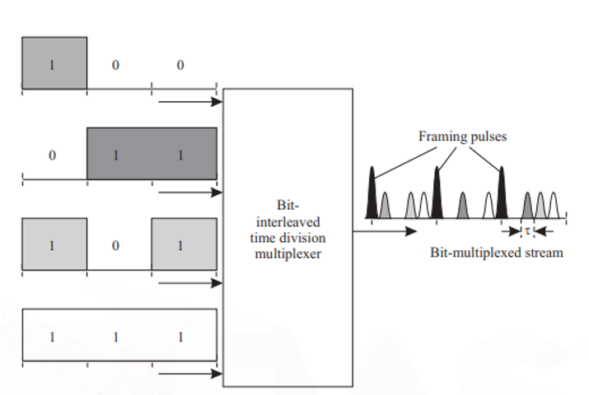

Figure 6 Function of Bit interleaved Optical multiplexer.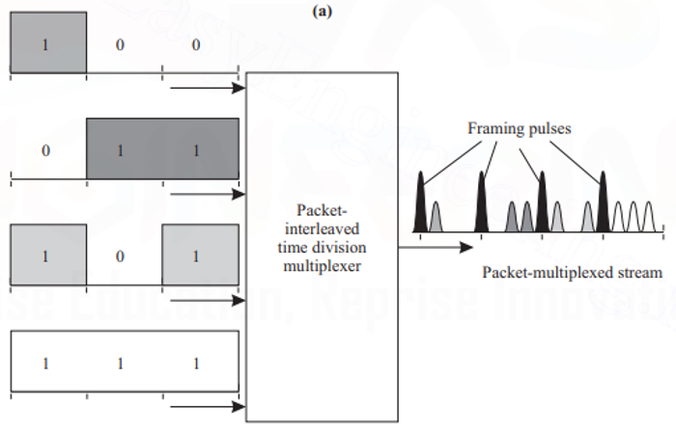

Figure 7 Function of Packet interleaved Optical multiplexer.

In both the bit-interleaved and the packet-interleaved case, framing pulses can be used. In the packet-interleaved case, framing pulses mark the boundary between packets. In the bit-interleaved case, if n input data streams are to be multiplexed, a framing pulse is used every n bits.

# Bit Interleaving

Multiplexing:-

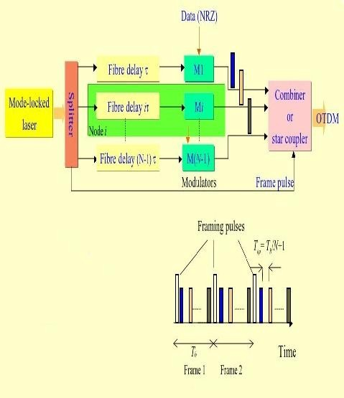Bit interleaving operation is illustrated in Figure 8. The periodic pulse train is generated by a mode-locked laser this pulse stream is split by using splitter, and one copy is created for each data stream to be multiplexed. The pulse train for the ith data stream, i = 1, 2,...,n, is delayed by iτ.

Figure 8 Bit interleaving Operation

This delay can be achieved by passing the pulse train through the different lengths of optical ﬁber. Since the velocity of light in silica ﬁber is about 2 × 108m/s, 1 meter of ﬁber provides a delay of about 5 ns. Thus, the delayed pulse streams are non-overlapping in time. The undelayed pulse stream is used for framing pulses.

Each delayed data stream is modulated by RZ, NRZ techniques, here we using NRZ techniques for modulation. The outputs of the modulator and the framing pulse stream are combined by using combiner and obtain the bit-interleaved optical TDM stream. The power level of the framing pulses is chosen higher than that of the data pulses. This will useful in demultiplexing to spread out the multiplexed OTDM signal.

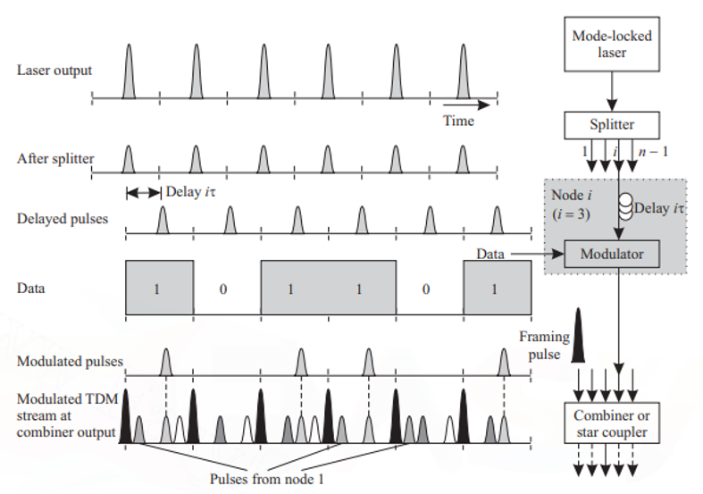

Figure 9 Bit interleaving Operation at single node

### Demultiplexing:-

Figure 10 Demultiplexer to extract one of the multiplexed channels from bit interleaving OTDM

The demultiplexing operation is illustrated in Figure 10. The multiplexed input is split into two streams using, a 3 dB coupler. If the jth stream from the multiplexed stream is to be extracted, one of these streams is delayed by jτ. A thresholding operation is performed on the delayed stream to extract the framing pulses. The framing pulses were multiplexed with higher power than the other pulses in order to facilitate this thresholding operation. Note that because of the induced delay, the

extracted framing pulses coincide with the pulses in the undelayed stream that correspond to the data stream to be demultiplexed. A logical AND operation between the framing pulse stream and the multiplexed pulse stream is used to extract the jth stream. The output of the logical AND gate is a pulse if, during a pulse interval, both inputs have pulses; the output has no pulse otherwise.

**Packet Interleaving:**

In the case of bit interleaving, modulated data stream has narrow pulses. if the bit interval T, then T separation is required to separate out two successive bit pulse. So, packet interleaving is required. The packet-interleaving operation is illustrated in Figure 11. In packet interleaving, it is required to reduce the interval between successive pulses to τ, corresponding to the higher-rate multiplexed signal. This can be done by passing modulated output from a series of compression stages.

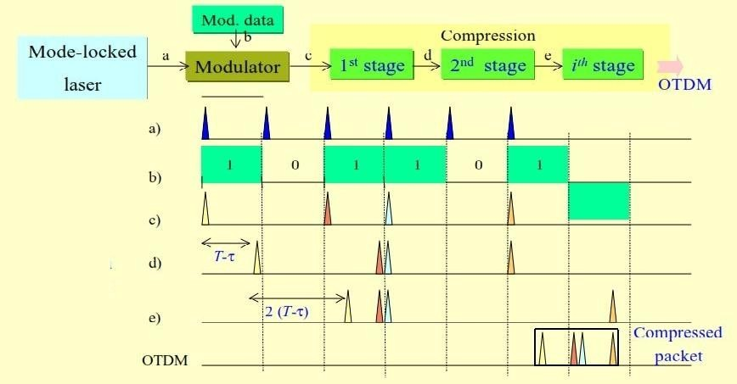

Figure 11. Packet interleaving Operation

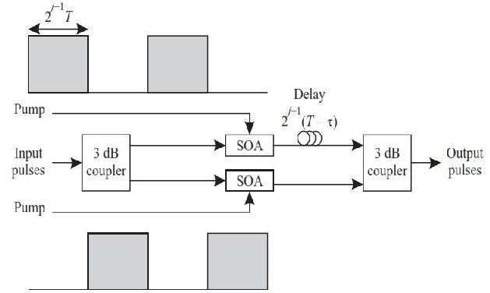If the size of each packet is l bits, then output must goes through k = [log2 l] compression stages. In the ﬁrst compression stage, bits 1, 3, 5, 7,... are delayed by T - τ . In the second compression stage, the pairs of bits (1, 2), (5, 6), (9, 10),... are delayed by 2(T - τ). In the third compression stage, the bits (1, 2, 3, 4), (9, 10, 11, 12),... are delayed by 4(T - τ).

Figure 12. Detailed view of compression stage j

The jth compression stage is shown in Figure 12. Each compression stage consists of a pair of 3 dB couplers, two semiconductor optical ampliﬁers (SOAs) used as on-off switches, and a delayline. The jth compressionstagehasadelaylineofvalue2 j-1(T-τ).

### 

### Demultiplexer

In Demultiplexing, a ﬁve AND gates are used to break up the incoming multiplexed high-speed stream into ﬁve parallel streams each with ﬁve times the pulse spacing of the multiplexed stream.

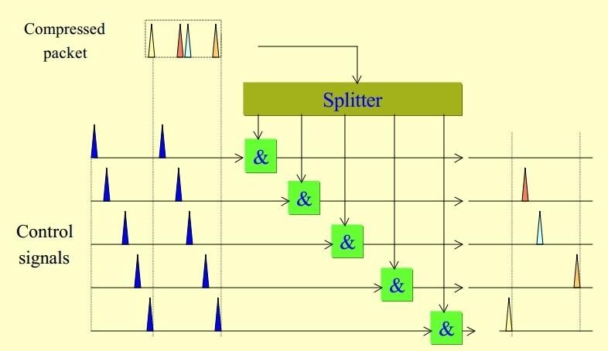

Figure 12. Demultiplexer to extract one of the multiplexed channels from packet interleaving OTDM

This procedure is identical to the one obtaining ﬁve bit-interleaved data streams. One input to each AND gate is the incoming data stream, and the other input is a control pulse stream where the pulses are spaced ﬁve times apart. The control pulse streams to each AND gate are appropriately offset from each other so that they select different pulses. Thus the ﬁrst parallel stream would contain bits 1, 6, 11,... of the packet, the second would contain bits 2, 7, 12,..., and so on. This approach can also be used to demultiplex a portion of the packet, for example, the packet header, in a photonic packet switch.

1. **Explain optical access network. What was the initial deployment and latest technology?**

* The classification of optical access network is dependent on the type of their distribution network, that means whether it is broadcast or switched. Depending upon the feeder network, optical access networks are classified as dedicated bandwidth or shared bandwidth networks.
* We have already discussed the telephone and cable networks in the previous section. Now-a-day some other techniques are also used to improve the performance of optical access network. The Integrated Services Digital Network (ISDN) gives the bandwidth of 144 kb/sec using same twisted pair network.
* In order to provide more bandwidth than ISDN; another technique called as Digital Subscriber Line (DSL) can be used for existing twisted pair network. It provides the bandwidth which is sufficient to transmit the compressed video signal.
* For this technique, it is required to have DSL modem, both at the central office as well as at the home.
* **The major drawback of DSL technique is that, the bandwidth in inversely proportional to the distance.**
* Geostationary satellite is another options to provide broadcast networking services. Geostationary satellite provides more bandwidth and it can handle large number of channels. Since a single satellite has to cover a wide area; it is difficult to handle the spatial reuse of bandwidth. Wireless access network is anotherbetter option but it is applicable for limited range. As well as it bandwidth is limited.
* **Two common wireless access networks are as follows :**
  + Multichannel Multipoint Distribution Services (MMDS)
  + Local Multipoint Distribution Services (LMDS)
* MMDS provides a bandwidth of 2 to 3 GHz and it can provide total 33 channels of 6 MHz each.
* LMDS provides a bandwidth of 1.3 GHz and it is more suitable of short range distances, typically 3 km to 5 km.

1. **Write a short note on FTTH Network?**

* In this case, the data is transmitted digitally from the Central Office (CO) to the fiber terminating nodes. The fiber terminating nodes are called as Optical Network Units (ONUs). Here the signals are broadcast from central office to ONUs. The ONUs share a common total bandwidth using time division multiplexing.
* Depending on the connection of fibers; different terms are used to describe the FTTC architecture. These are as follows :
  + Fiber To The Home (FTTH)
  + Fiber To The Building (FTTB)
  + Fiber To The Cabinet (FTTCab)

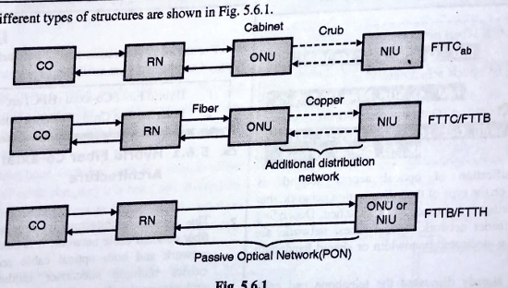

* 1. **FTTH:** In this case connection to every home is using optical fibers. The Optical Network Units (ONUs) perform the job of Network Interfacing Units (NIUs).
  2. **FTTB:** In this case the fiber connection is upto the building or a group of 8 to 64 homes. Here an additional distribution network is required from ONU to NIU.
  3. **FTTCab:** As the name indicates; optical fiber is terminated into the cabinet. Usually the fiber cable is within 1 km range from individual home. Basically in case of FTTC architecture; the Remote Nodes (RNs) are placed in the Central Office (CO) and not in the field. The network from CO to ONU is Passive Optical Network (PON).

1. **Explain in brief different types of PON (passive optical network) architecture? How Passive optical network functions? How it differs from WDM Network**

* The different structure are available to realize the optical access network. Usually passive architectures are preferred over active architectures because in passive architecture, the network does not contain any switching and controlling of network is not required. In passive architecture, the passive components are used for example an optical star coupler is used as remote node.
* The optical path which consists of passive components like fibers, couplers and connectors, is called as Optical Distribution Network (ODN).
* For FTTCab, ONU (Optical Network Unit) is located at the crub and for FTTH or FTTB, ONU is located at the end user location. This provides broadband voice, data and video services.

**PON Architectures**

**The various PON architectures are as follows :**

1. All fiber PON 2. TPON 3. WPON 4. WRPON

**All fiber PON**

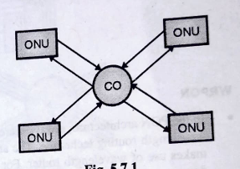

* It is the simplest PON architecture as shown in Fig.
* Here each ONU is connected to the Central Office (CO) using pair of optical fibers.
* Practically the fibers are arranged in the form of ring.
* A pair of fiber is used for bidirectional communication.
* We can use a single optical cable between CO and ONU; but for bidirectional communication same wavelength cannot be used.
* For upward and downward communication; a separate wavelength is to be used. But if we use single wavelength then using time division multiplexing approach; bidirection communication can be achieved.
* Use of a separate optical fiber cable for each ONU, increases the total cost of system. Instead of this, a single pair of fiber can be shared by many users for example SONET or SDH ring.

**TPON**

* TPON stands for PON used for telephony. This architecture is shown in Fig. A laser transmitter used in CO, broadcasts the downstream traffic to all ONUs using a passive star coupler. For upstream traffic, all ONUs use a single channel using time division multiplexing approach.
* The upstream and downstream signals are transmitted through a single optical cable, by using different wavelengths.
* The laser transmitter used in CO, transmits a wavelength of 1.55 um and laser transmitter used in ONU, transmits a wavelength of 1.33 um.

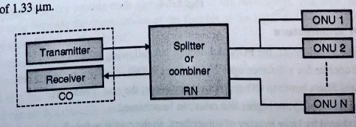

**WPON**

* It represents implementation of WDM in TPON. This architecture is shown in Fig.
* Here the CO consists of WDM array of transmitters or it may contain a single laser transmitter which is tunable. The central office, broadcasts multiple wavelengths and each ONU selects a particular wavelength.
* In this case the data transmission takes place at the rate of receiving data. The optical network units share upstream and downstream channels at different wavelengths.

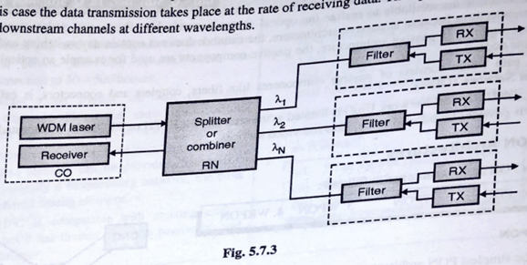

**WRPON**

* In the PON architecture; always there is a problem of power splitting at the star coupler. It can be avoided by using wavelength routing technique. The architecture of Wavelength Routing PON (WRPON) is shown in Fig. It makes use of wavelength router. For this purpose the Arrayed Waveguide Grating (AWG) is used to monitor the downstream traffic.
* AWG routes different wavelengths to different ONUs for the downstream traffic. For the upstream traffic; ONU time shares the wavelength.

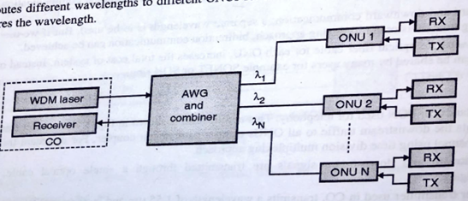

**Advantages of PON Architecture**

* A local loop PON can operate for a distance upto 20 km whereas DSL can operate upto 6 km.
* Due to sharing of optical fibers between CO and optical combiner; the cost is reduced.
* PON provides higher data capacity, so higher line rates can be achieved.
* Electronic devices are shared by large number of subscribers, so the cost is reduced.

**Module 6**

1. **Define crosstalk. What are the types of crosstalk in optical transmission system? Method to reduce crosstalk**

Crosstalk is the general term given to the effect of other signals on the desired signal. Almost every component in a WDM system introduces crosstalk of some form or another. The components include filters, wavelength multiplexers/demultiplexers, switches, semiconductor optical amplifiers, and the fiber itself (by way of nonlinearities).

Two forms of crosstalk arise in WDM systems:

1. Interchannel crosstalk
2. Intrachannel crosstalk.

* The first case is when the crosstalk signal is at a wavelength sufficiently different from the desired signal’s wavelength that the difference is larger than the receiver’s electrical bandwidth. This form of crosstalk is called interchannel crosstalk. Interchannel crosstalk can also occur through more indirect interactions, for example, if one channel affects the gain seen by another channel, as with nonlinearities.
* It is a crosstalk taking place due to mixing of data between two channels.
* In case of WDM system, a filter is used to receive the data from desired channel and to reject the data from remaining channels.
* Here the data from two adjacent channels gets mixed and it represents interchannel crosstalk.
* Similarly, in case of demultiplexer, one particular channel should be selected at a time. But the demultiplexer does not perfectly rejects other channels, so mixing of data between two channel takes place.

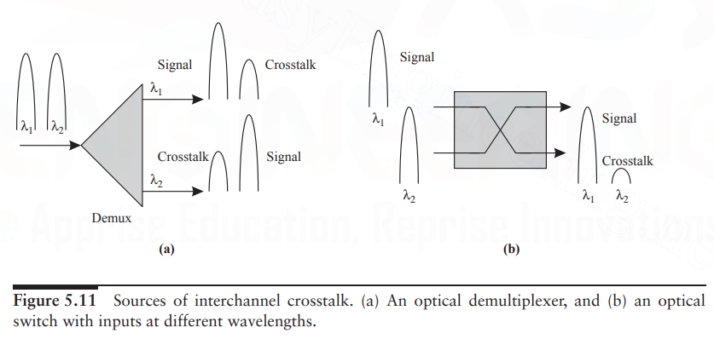

* The second case is when the crosstalk signal is at the same wavelength as that of the desired signal or sufficiently close to it that the difference in wavelengths is within the receiver’s electrical bandwidth. This form of crosstalk is called intrachannel crosstalk or, sometimes, coherent crosstalk.

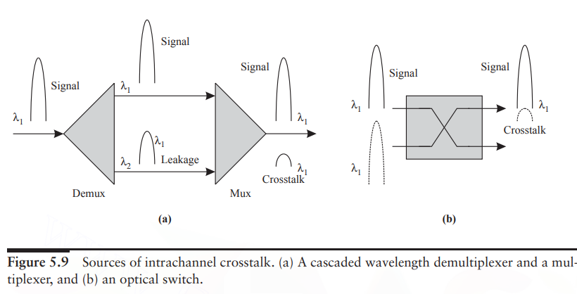

**To reduce the crosstalk, usually two methods are used:**

* Spatial dialiation
* Wavelength dialiation

**1. Spatial dialiation**

* Consider an example of 2 x 2 optical switch as shown in Fig (a) . Here the crosstalk is ϵ.
* Now, dialiation means addition of extra ports to the switch as shown in Fig. (b). Here some unused extra ports are added and the crosstalk is reduced to ϵ 2. But the drawback of this method is, it is required to increase the number of switches.

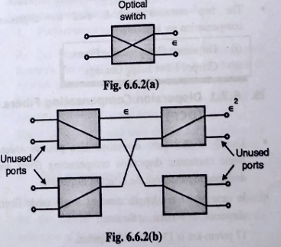

**2. Wavelength dialiation**

* This method is used when single switch is used for multiple wavelengths.
* Instead of one switch; two switches are used to reduce interchannel crosstalk.

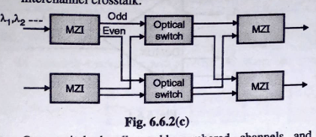

* One switch handles odd numbered channels and another handles even numbered channel.
* The Mach-Zehnder Interferrometer (MZI) is used to separate the channels into two groups and again to combine them as shown in Fig.(c).

1. **Explain the various management functions**

**1. Performance management** deals with monitoring and managing the various parameters that measure the performance of the network. Performance management is an essential function that enables a service provider to provide quality-of-service guarantees to their clients and to ensure that clients comply with the requirements imposed by the service provider. It is also needed to provide input to other network management functions, in particular, fault management, when anomalous conditions are detected in the network.

**2. Fault management** is the function responsible for detecting failures when they happen and isolating the failed component. The network also needs to restore traffic that may be disrupted due to the failure, but this is usually considered a separate function.

**3. Configuration management** deals with the set of functions associated with managing orderly changes in a network. The basic function of managing the equipment in the network belongs to this category. This includes tracking the equipment in the network and managing the addition/removal of equipment, including any rerouting of traffic this may involve and the management of software versions on the equipment.

Another aspect of configuration management is connection management, which deals with setting up, taking down, and keeping track of connections in a network. This function can be performed by a centralized management system. Alternatively, it can also be performed by a distributed network control entity. Distributed network control becomes necessary when connection setup/take-down events occur very frequently or when the network is very large and complex.

**A. Connection management:**

* Centralized management system-setting up, taking down, and keeping track of connections in a network.
* Distributed network control-setup/take-down events occur very frequently or when the network is very large and complex.

**B. Adaptation management:**

* Network needs to convert external client signals entering the optical layer into appropriate signals inside the optical layer.

**4. Security management** includes administrative functions such as authenticating users and setting attributes such as read and write permissions on a per-user basis. From a security perspective, the network is usually partitioned into domains, both horizontally and vertically.

* Vertical partitioning implies that some users may be allowed to access only certain network elements and not other network elements. For example, a local craftsperson may be allowed to access only the network elements he is responsible for and not other network elements.
* Horizontal partitioning implies that some users may be allowed to access some parameters associated with all the network elements across the network. For example, a user leasing a lightpath may be provided access to all the performance parameters associated with that lightpath across all the nodes that the light path traverses.

Security also involves protecting data belonging to network users from being tapped or corrupted by unauthorized entities. This part of the problem needs to be handled by encrypting the data before transmission and providing the decrypting capability to legitimate users.

**5. Accounting management** is the function responsible for billing and for developing lifetime histories of the network components. This function is the same for optical networks.

1. **Write short note on : Optical safety**

The semiconductor lasers used in optical communication systems are relatively low-power devices; nevertheless, their emissions can cause serious damage to the human eye, including permanent blindness and burns. The closer the laser wavelength is to the visible range, the more damage it can do, since the cornea is more transparent to these wavelengths. For this reason, systems with lasers must obey certain safety standards. Systems with lasers are classified according to their emission levels, and the relevant classes for communication systems . In some cases, these safety issues can limit the allowable optical power used in the system.

* A Class I system cannot emit damaging radiation. The laser itself may be a high-power laser, but it is prevented from causing damage by enclosing it in a suitably interlocking enclosure. The maximum power limit in a fiber for a Class I system is about 10 mW (10 dBm) at 1.55 μ m and 1 mW(0 dBm) at 1.3 μ m. Moreover, the power must not exceed this level eve n under a single failure condition within the equipment. A typical home CD player, for example, is a Class I system.
* A Class IIIa system allows higher emission powers—up to 17 dBmin the 1.55 μ m wavelength range—but access must be restricted to trained service personnel. Class IIIa laser emissions are generally safe unless the laser beam is collected or focused onto the human eye.
* A Class IIIb system permits even higher emission powers, and the radiation can cause eye damage even if not focused or collected. Under normal operation, optical communication systems are completely “enclosed” systems—laser radiation is confined to within the system and is not seen outside. The problem arises during servicing or installation, or when there is a fiber cut, in which case the system is no longer completely.

enclosed and emission powers must be kept below the levels recommended for that particular system class. Communication systems deployed in the enterprise world must generally conform to Class I standards since untrained users are likely to be using them. Systems deployed within carrier networks, on the other hand, may likely be Class IIIa systems, since access to these systems is typically restricted to trained service personnel. The safety issue thus limits the maximum power that can be launched into a fiber.

For single-channel systems without optical power amplifiers using semiconductor lasers, the emission levels are small enough (− 3 to 0 dBm typically) that we do not have to worry much about laser safety. However, with WDM systems, or with systems using optical power amplifiers, we must be careful to regulate the total power into the fiber at all times.

1. **Write a short note on : Free space optics. (2M)**

* Free space optics is a communication system where free space acts as medium between transceivers and they must be in LOS for successful transmission of optical signal. FSO Communication medium can be air, outer space, or vacuum. There is no need of the optical fiber cable.
* FSO is an optical communication technique which broadcasts light in free space such as air, vacuum or space, to transfer data wirelessly. It offers high data rates up to 2.5 Gbps over a range of 100 m to a few kilometers. It has ability to replace the traditional means of communications in a wide variety of applications. FSO system includes an optical transceiver at both ends in order to provide full duplex (bidirectional) capability. FSO is a line of sight (LOS) technology, where data, voice, and video communication is achieved with maximum 10 Gbps of data rate by full duplex (bidirectional) connectivity.

**Characteristics:**

- An effective FSO system must have the following characteristics :

* It should operate at higher power levels for longer distance.
* High speed modulation is important for high speed FSO systems.
* FSO system design should have small footprint and low power consumption because of its maintenance.
* It should operate over wide temperature range and the performance degradation will be less for outdoor systems.
* Mean time between failures (MTBF) of FSO system should be more than 10 years.

**Block Diagram of FSO:**

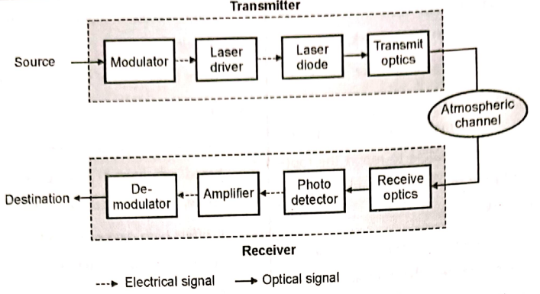

FSO system consist of:

1. Transmitter.

2. Atmospheric channel.

3. Receiver:

**1. Transmitter:**

The transmitter converts the information to a signal form which is suitable for transmission over the atmospheric channel. The role of modulator is to modulate the data for transmission by using various modulation techniques. The function of modulator is to modulate the information signal and drive the laser driver.

Laser diode is preferred because it has quality of high pointedness and consistency that its beam displays. The laser diode converts the information in the electrical domain to an optical signal. The function of transmit optics is to collect the laser light and direct it towards the receiver.

**2. Atmospheric Channel:**

In FSO system, the atmospheric channel can be vacuum, atmosphere, or water. In the atmospheric channel, the signal faces random attenuation due to fog, haze, cloud and rain. Atmospheric turbulence in FSO link is the main limiting factor for its performance. Atmospheric turbulence causes the degradation of the optical beam of transmission

**3. Receiver:**

The incident optical signal is captured by the receive optics, and it send this signal on the photodetector. A photodetector converts the received optical signal to electrical signal. Then the amplifier amplifies the signal and increases the SNR. Modulation and demodulation of the signal takes place in electrical form. Demodulation of received signal takes place and the signal is formed in the preferred form at the destination.

**Applications of FSO :**

* **Outdoor wireless access:** Wireless service providers can use FSO for communication and no license is required to use the FSO.
* **Storage Area Network (SAN):** FSO links can be used to form a SAN. SAN is a network which provides access to consolidated, block level data storage.
* **Last-mile access:** It is high speed link and used in last mile access and to bypass local-loop systems of other types of networks.
* **Enterprise Connectivity:** FSO systems can be installed easily. It is used in interconnecting LAN segments to connect two buildings or other property.
* **Fiber backup:** FSO can provide a backup link in case of failure of transmission through fiber link.
* **Metro-network extensions:** FSO system can be installed in less time and connection of the new networks and core infrastructure is easily done. It can be to complete SONET rings.
* **Backhaul:** FSO can carry the traffic of cellular telephone from antenna towers back to the PSTN with high speed and high data rate.
* **Service acceleration:** It provides instant service to customers.
* **Bridging WAN Access:** FSO is useful in WAN where it supports high speed data services for mobile users and small satellite terminals and it acts as a backbone for high speed trunking network.
* **Communication:** FSO can be used to communicate between point-to- point links (two buildings, two ships), - point-to-multipoint links (from aircraft to ground or satellite to ground) and short and long reach communication.
* **Military access:** FSO is a secure and undetectable system hence it can connect large areas safely with minimum planning and deployment time. Hence FSOs are suitable for military applications.

**Merits of FSO:**

1. FSO systems delivers better speed than broadband systems.
2. Installation of FSO is easy and it takes less time to install FSO at normal locations.
3. It requires very low initial investment.
4. FSO system do not need spectrum license or frequency coordination between users.
5. It is a secure because of line of sight operation and no need of security system upgradation.
6. FSO systems are immune to radio frequency interference.
7. The transmission in FSO link is not affected by electromagnetic and radio-magnetic interference.
8. It offers low power usage per transmitted bit.
9. FSO provides high bandwidth.
10. FSO has flexible rollouts.
11. FSO is a high speed communication system as transmission involves optical beam.
12. It has low cost and simple deployment.
13. FSO system low power usage per transmitted bit, low bit error rates, full duplex operation.
14. No need to connect the transmitter and receiver through a waveguide as the transmission is free space.

**Disadvantages of FSO:**

1. Spreading loss in FSO link is higher and there is atmospheric loss due to water and carbon dioxide molecules.
2. High power consumption.
3. It is less secure as compared to OFC.
4. Transmitter ‘and receiver must be in LOS (Line of Sight) to each other for FSO operation.
5. The FSO transmitted signal can be blocked due to trees, animals, tall buildings and other atmospheric conditions.
6. Birds and scintillation results in beam interruptions. Hence availability of FSO link depends on weather conditions.

**Challenges in FSO:**

* **Physical obstructions :**

The flying birds, trees and tall buildings can momentarily block a single beam, when it come into view of line of sight (LOS) of transmission of FSO system.

* **Scintillation :**

The temperature variations results in the fluctuations in amplitude of the signal which causes “image dancing” at the FSO receiving end.

* **Geometric losses :**

Geometric losses which can be called optical beam attenuation are induced due to the spreading of beam and reduced the power level of signal as it travelled from transmitted end to receiver end.

* **Absorption :**

A FSO system is directly affected by absorption as the power density of the optical beam is reduced.

* **Atmospheric turbulence :**

The atmospheric disturbance occurs due to structure of weather and environment. Atmospheric turbulence causes the degradation of the optical beam of transmission.

* **Atmospheric attenuation / Weather conditions :**

Atmospheric attenuation causes due to fog and haze and it depends on dust and rain. In a FSO transmission. Attenuation depends on several weather conditions like fog, rain, haze, smoke, sandstorms, link, atmosphere is the medium of clouds etc.

**Sums**

1. An analog optical fiber system employs an LED which emits3 dBm mean optical powerinto air. However, a coupling loss of 17.5 dB is encountered when launching into a fibercable. The fiber cable which extends for 6 km without repeaters exhibits a loss of 5 dB.km-1It is spliced every 1.5 km with an average loss of 1.1 dB per splice. In addition, there is aconnector loss at the receiver of 0.8 dB. The PIN-FET receiver has a sensitivity of - 54 dBmat the operating bandwidth of the system. Assuming there is no dispersion-equalization penalty, perform an optical power budget for the system and establish a safety margin.
2. An optical fiber system is to be designed to operate over an 8 km length without repeaters. The rise times of the components are:

Source(LED) = 8ns

Fiber: Intermodal = 5 ns/km and Intramodal = 1 ns/km

Detector (pin photodiode) = 6 ns

From system rise time considerations, estimate the maximum bit rate that may be achieved on the link when using an NRZ format.